**Program-1a)**

**Aim: Demonstrate all the basic tags in html5 for Formatting tags.**

**Source code:**

i)**Physical Formatting Tags**

<!DOCTYPE html>

<html>

<head>

<title>physical tags</title>

</head>

<body>

Bec Bapatla Engineering College<br>

<i>Bec Bapatla Engineering College</i><br>

<b>Bec Bapatla Engineering College</b><br>

<big>Bec Bapatla Engineering College</big><br>

<small>Bec Bapatla Engineering College</small><br>

<u>Bec Bapatla Engineering College</u><br>

Bec<sub>Bapatla Engineering College</sub><br>

Bec<sup>Bapatla Engineering College</sup>

</body>

</html>

**Output:**

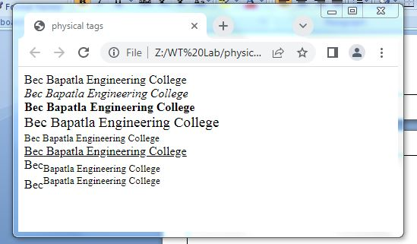

**ii)Logical Formatting Tags**

**Source Code:**

<!DOCTYPE html>

<html>

<head>

<title>logicaltags</title>

</head>

<body>

<abbr title="Hypertest markup language">HTML</abbr>

is used to develop the web pages<br><br>

click<kbd>here</kbd>to run program<br><br>

this is <em>emphasized test</em><br><br>

bec<strong>bapatla</strong>college<br><br>

<dfn title="Hypertest markup language">HTML</dfn>

is used to develop webpages.<br><br>

<q>welcome to bec</q><br><br>

<blockquote>this is HTML class</blockquote/> <br><br>

inserted content<ins>ECE,IT,EEE,CSE</ins><br><br>

deleted test <del>MECH,CIVIL,AI,CB</del><br><br>

This is <mark>marked test</mark><br><br>

<bdo dir="ltr">this is HTML class</bdo><br><br>

<bdo dir="rtl">this is HTML class</bdo><br><br>

</body>

</html>

**Output:**

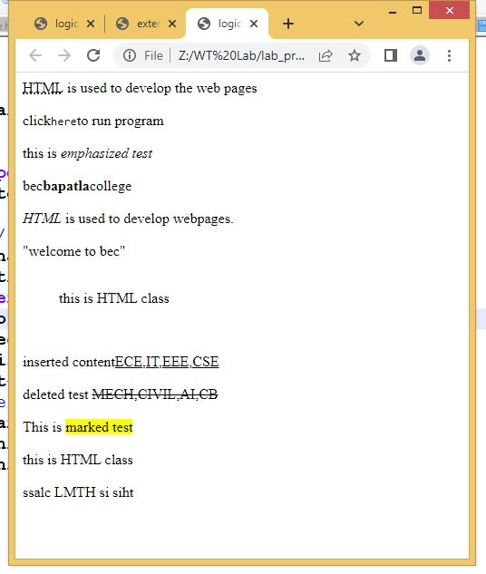

**Program-1b)**

**Aim: Demonstrate all the basic tags in html5 for representing various lists**

**Source code:**

<!DOCTYPE html>

<html>

<head>

<title>list</title>

</head>

<body>

<ol>

<li>milk</li>

<li>tea</li>

<li>coffee</li>

</ol>

<ul>

<li>milk</li>

<li>tea</li>

<li>coffee</li>

</ul>

<dl>

<dt>HTML</dt>

<dd>HTML is the standard markup language for Web pages.</dd>

<dt>ECE</dt>

<dd> ECE is Electronics and Communication Engineering</dd>

</dl>

</body>

</html>

**Output:**

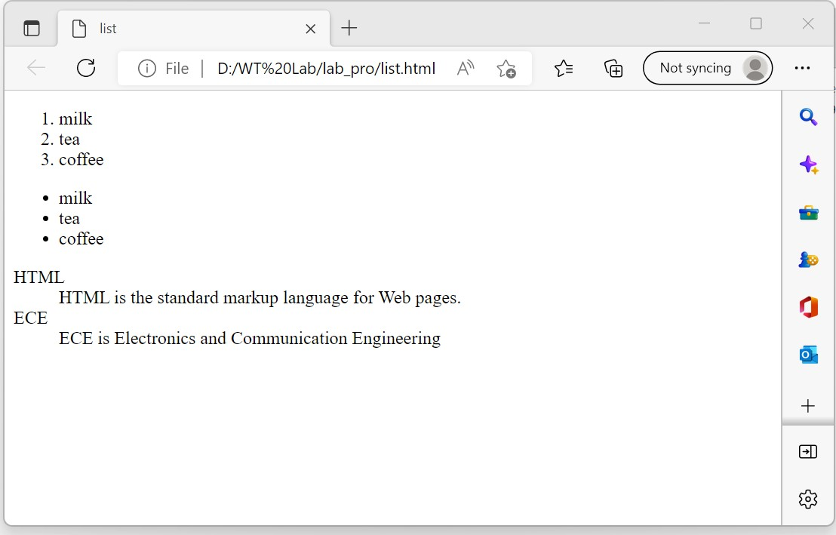

**Program1c)**

**Aim: Demonstrate all the basic tags in html5 for timetable Creation**

**Source code:**

<!DOCTYPE html>

<html>

<head>

<title>Time Table</title>

</head>

<body>

<div style="width:2%;float:left" align="right">

<img src="beclo.jpeg " width="90" height="90">

</div>

<div style="width:98%;float:center">

<p align="center"><b>Bapatla Engineering College </span></b> <br>

(Autonomus) <br>

Department of Information Technology <br>

. <span style="color:brown"> <i>Class Time Table for the

<span style="background- color:yellow">

<u> A.Y2021-22,IV Semester </u> </span> </i> </span> </p>

</div>

<hr>

<div style="float:left">

<table>

<td colspan="2"><i>w.e.f:</i>28-03-2022</td>

<td><pre> </pre></td>

<td colspan="2"><i>Class:</i>2 II B.Tech,IT</td>

<td><pre> </pre></td>

<td colspan="2"><i>Section:</i>2A</td>

<td><pre> </pre></td>

<td colspan="2"><i>Room No:</i>2RPLH-03</td>

</table>

<table border="2">

<tr style="background-color:orange">

<th>Time <br>Day</th>

<th>7:30-<br>8:20</th>

<th>8:20-<br>9:10</th>

<th>9:10-<br>10:00</th>

<th rowspan="7">B<br>R<br>E<br>A<br>K</th>

<th>10:30-<br>11:20</th>

<th>11:20-<br>12:10</th>

<th>12:10-<br>01:00</th>

</tr>

<tr align="center">

<th style="background-color:orange">Mon</th>

<td>PHEV</td>

<td>DAA</td>

<td><small>PYTHON<br>PROGRAMMING</small></td>

<td>WT</td>

<td>p&s </td>

<td>DBMS</td>

</tr>

<tr align="center">

<th style="background-color:orange">Tues</th>

<td colspan="3">WT/RDBMS LAB</td>

<td>DBMS</td>

<td><small>PYTHON<br>PROGRAMMING</small></td>

<td>WT</td>

</tr>

<tr align="center">

<th style="background-color:orange">Wed</th>

<td>p&s</td>

<td>DAA</td>

<td>WT</td>

<td colspan="3">RDBMS/Python Prog.lab </td>

</tr>

<tr align="center">

<th style="background-color:orange">Thus</th>

<td>PHEV</td>

<td><small>PYTHON<br>PROGRAMMING</small></td>

<td>DBMS</td>

<td>p&s </td>

<td>WT</td>

<td>DAA</td>

</tr>

<tr align="center">

<th style="background-color:orange">Fri</th>

<td colspan="3">Python Prog./WT Lab</td>

<td>PHEV</td>

<td>DAA</td>

<td>DBMS</td>

</tr>

<tr align="center">

<th style="background-color:orange">Sat</th>

<td>DAA</td>

<td>DBMS</td>

<td>p&s </td>

<td>PHEV</td>

<td>WT</td>

<td style="background-color:yellow">Mentoring</td>

</tr>

</table>

</div>

<div style="width:80%;float:right">

<table>

<th style="background-color:yellow;color:white">

Section Coordinator: Mr.K.Suresh Kumar,Asst.Professor</th>

</table>

</div>

<div style="float:left">

<table>

<tr style="background-color:orange" align="left">

<th>Sub.Code</th>

<th>Sub.Name</th>

<th>Faculty.Name</th>

<th>Sub.Code</th>

<th>Sub.Name</th>

<th>Faculty.Name</th>

</tr>

<tr align="left">

<th>20IT401/MA03</th>

<td>P&S </td>

<td>Mr.I.Pothuraju </td>

<th>20ITL401</th>

<td>WT Lab</td>

<td>Mr.Sk.Mabasha</td>

</tr>

<tr align="left">

<th>20IT402</th>

<td>WT</td>

<td>Mr.Sk.Mabasha</td>

<th>20ITL402</th>

<td>RDBMS Lab</td>

<td>Mr.P.Ravi Kumar</td>

</tr>

<tr align="left">

<th>20IT403</th>

<td>DBMS</td>

<td>Mr.P.Ravi Kumar</td>

<th>20ITL403 /</th>

<td>Python</td>

<td>Mr.K.Suresh Kumar</td>

</tr>

<tr align="left">

<th>20IT404</th>

<td>DAA</td>

<td>Prof.N.Sivarama Prasad</td>

<th>SO02</th>

<td>Prog.Lab</td>

</tr>

<tr align="left">

<th>MC02</th>

<td>PEHV</td>

<td>Dr.K.Srinivasa Rao</td>

</tr>

</div>

</table>

<hr>

<div style="width:100;float:left">

<table>

<td colspan="2"><i>w.e.f:</i>28-03-2022</td>

<td><pre> </pre></td>

<td colspan="2"><i>Class:</i>2 II B.Tech,IT</td>

<td><pre> </pre></td>

<td colspan="2"><i>Section:</i>2B</td>

<td><pre> </pre></td>

<td colspan="2"><i>Room No:</i>2RPLH-04</td>

</table>

<table border="2">

<tr style="background-color:orange">

<th>Time <br>Day</th>

<th>7:30-<br>8:20</th>

<th>8:20-<br>9:10</th>

<th>9:10-<br>10:00</th>

<th rowspan="7">B<br>R<br>E<br>A<br>K</th>

<th>10:30-<br>11:20</th>

<th>11:20-<br>12:10</th>

<th>12:10-<br>01:00</th>

</tr>

<tr align="center">

<th style="background-color:orange">Mon</th>

<td colspan="3">WT/RDBMS LAB</td>

<td>DBMS</td>

<td>DAA</td>

<td>WT </td>

</tr>

<tr align="center">

<th style="background-color:orange">Tues</th>

<td>PEHV</td>

<td>p&s</td>

<td><small>PYTHON<br>PROGRAMMING</small></td>

<td>WT</td>

<td>DAA</td>

<td>DBMS</td>

</tr>

<tr align="center">

<th style="background-color:orange">Wed</th>

<td>DAA</td>

<td>DBMS</td>

<td>p&s</td>

<td><small>PYTHON<br>PROGRAMMING</small></td>

<td>WT</td>

<td>PEHV</td>

</tr>

<tr align="center">

<th style="background-color:orange">Thus</th>

<td>WT</td>

<td>PHEV</td>

<td>DAA</td>

<td colspan="3">RDBMS/Python Prog.lab </td>

</tr>

<tr align="center">

<th style="background-color:orange">Fri</th>

<td><small>PYTHON<br>PROGRAMMING</small></td>

<td>p&s</td>

<td>DAA</td>

<td>DBMS</td>

<td>WT</td>

<td>PHEV</td>

</tr>

<tr align="center">

<th style="background-color:orange">Sat</th>

<td colspan="3">Python Prog./WT Lab</td>

<td>DBMS</td>

<td>p&s </td>

<td style="background-color:yellow">Mentoring</td>

</tr>

</table>

</div>

<div style="width:80%;float:right">

<table>

<th style="background-color:yellow;color:white">

Section Coordinator: Mr.SK.Mabasha,Asst.Professor</th>

</table>

</div>

<div style="float:left">

<table>

<tr style="background-color:orange" align="left">

<th>Sub.Code</th>

<th>Sub.Name</th>

<th>Faculty.Name</th>

<th>Sub.Code</th>

<th>Sub.Name</th>

<th>Faculty.Name</th>

</tr>

<tr align="left">

<th>20IT401/MA03</th>

<td>P&S </td>

<td>Mr.N.Karunakar</td>

<th>20ITL401</th>

<td>WT Lab</td>

<td>Mr.Sk.Mabasha</td>

</tr>

<tr align="left">

<th>20IT402</th>

<td>WT</td>

<td>Mr.Sk.Mabasha</td>

<th>20ITL402</th>

<td>RDBMS Lab</td>

<td>Mr.P.Ravi Kumar</td>

</tr>

<tr align="left">

<th>20IT403</th>

<td>DBMS</td>

<td>Mr.P.Ravi Kumar</td>

<th>20ITL403 /</th>

<td>Python</td>

<td>Mr.K.Sai Prasanth</td>

</tr>

<tr align="left">

<th>20IT404</th>

<td>DAA</td>

<td>Mr.P.Ratna Prakash</td>

<th>SO02</th>

<td>Prog.Lab</td>

</tr>

<tr align="left">

<th>MC02</th>

<td>PEHV</td>

<td>Dr.K.Srinivasa Rao</td>

</tr>

</div>

</table>

</body>

</html>

**Output:**

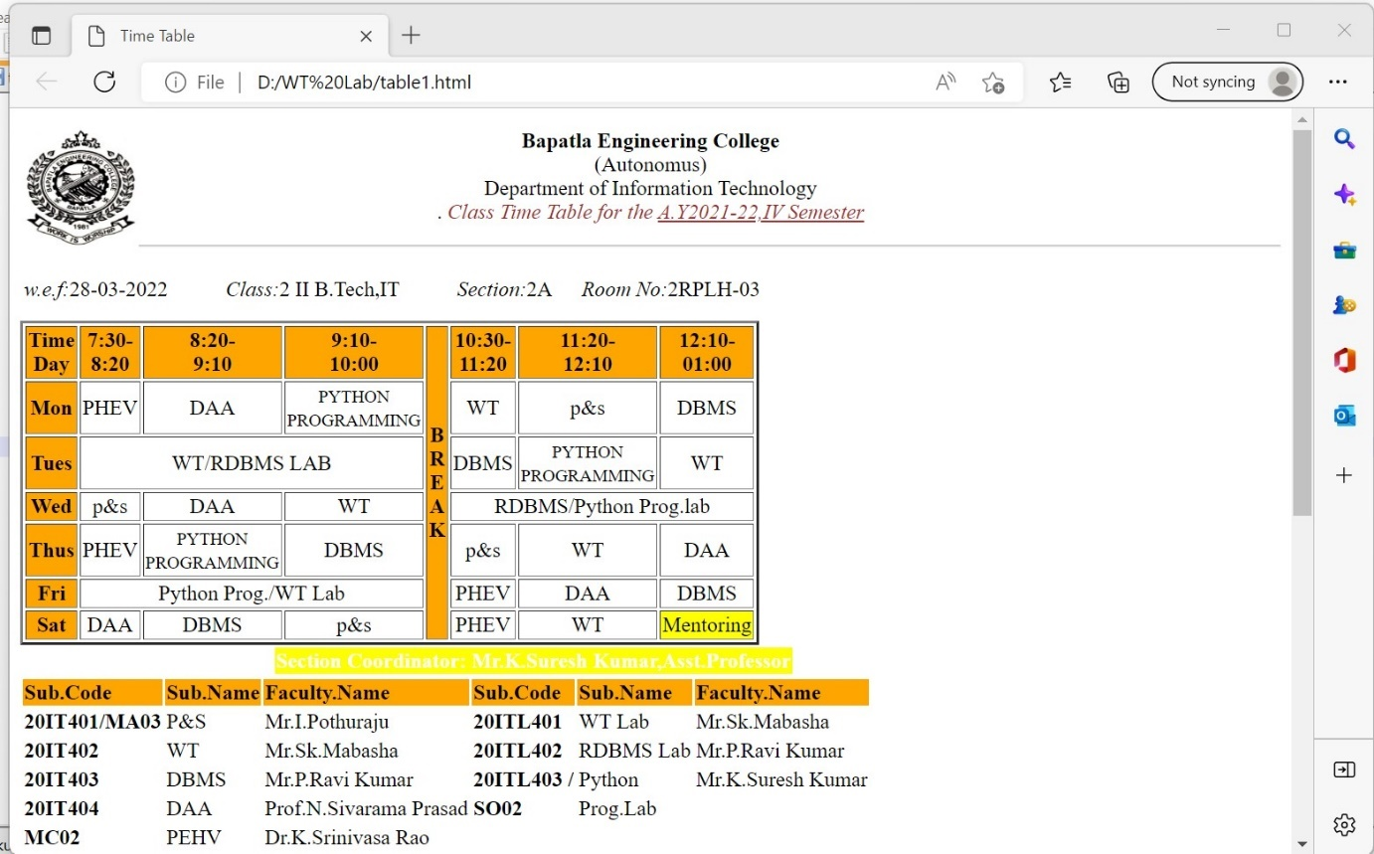

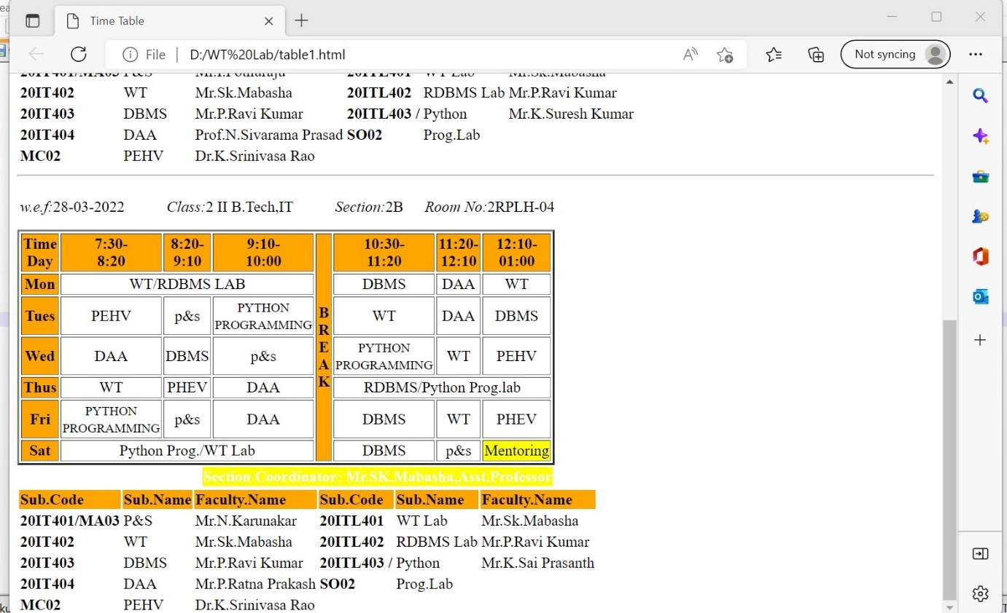

**Program-2a)**

**Aim: Demonstrate all the basic tags in html5 for describing internal,external and image as link.**

**Source code:**

<!DOCTYPE html>

<html>

<head>

<title>hyper links</title>

</head>

<body>

<h1><center>WORKING WITH HYPER LINKS</center></h1><br>

<a href="http://www.becbapatla.ac.in/"> <h2> click here go to bec web page</h2> </a> <br>

<a href="///Z:/WT Lab/1478257721php5lryn0.png"> <h2></h2><img src="1478257721php5lryn0.png"></a><br>

<a href="http://www.becbapatla.ac.in/"><img src ="picture.png" alt=width="200" height='300'><h2>click on image go to bec web page</h2></a><br>

<br>

<a href="http://www.becbapatla.ac.in/" target="_bec"><h2>Visit bec web page with new web page</h2> </a>

<a id="top"></a>

<h1> top of the page </h1>

<a href="#bottom"> click to bottom</a><br>

<a href="#center"> click to center</a>

<br>

<h1>WORKING WITH HYPER LINKS</h1><br>

<h1>WORKING WITH HYPER LINKS</h1><br>

<h1>WORKING WITH HYPER LINKS</h1><br>

<h1>WORKING WITH HYPER LINKS</h1><br>

<h1>WORKING WITH HYPER LINKS</h1><br>

<h1>WORKING WITH HYPER LINKS</h1><br>

<h1>WORKING WITH HYPER LINKS</h1><br>

<h1>WORKING WITH HYPER LINKS</h1><br>

<h1>WORKING WITH HYPER LINKS</h1><br>

<h1>WORKING WITH HYPER LINKS</h1><br>

<h1>WORKING WITH HYPER LINKS</h1><br>

<a id="center"></a>

<a href="#center"><h2> go to center</h2></a>

<a href="#TOP"><h2> go to top</h2></a>

<h1>WORKING WITH HYPER LINKS</h1><br>

<h1>WORKING WITH HYPER LINKS</h1><br>

<h1>WORKING WITH HYPER LINKS</h1><br>

<h1>WORKING WITH HYPER LINKS</h1><br>

<h1>WORKING WITH HYPER LINKS</h1><br>

<h1>WORKING WITH HYPER LINKS</h1><br>

<h1>WORKING WITH HYPER LINKS</h1><br>

<h1>WORKING WITH HYPER LINKS</h1><br>

<h1>WORKING WITH HYPER LINKS</h1><br>

<h1>WORKING WITH HYPER LINKS</h1><br>

<h1>WORKING WITH HYPER LINKS</h1><br>

<h1>WORKING WITH HYPER LINKS</h1><br>

<a id="bottom"></a>

<a href="#TOP"><h2> go to top</h2></a>

<a href="#center"><h2> go to center</h2>

</body>

</html>

**Output:**

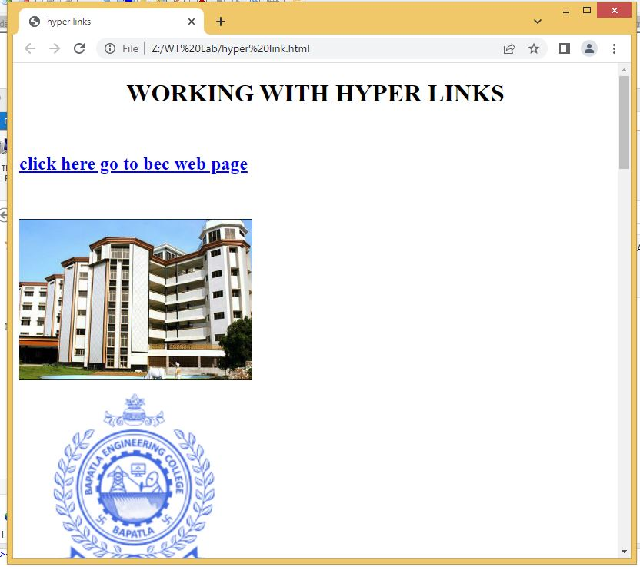

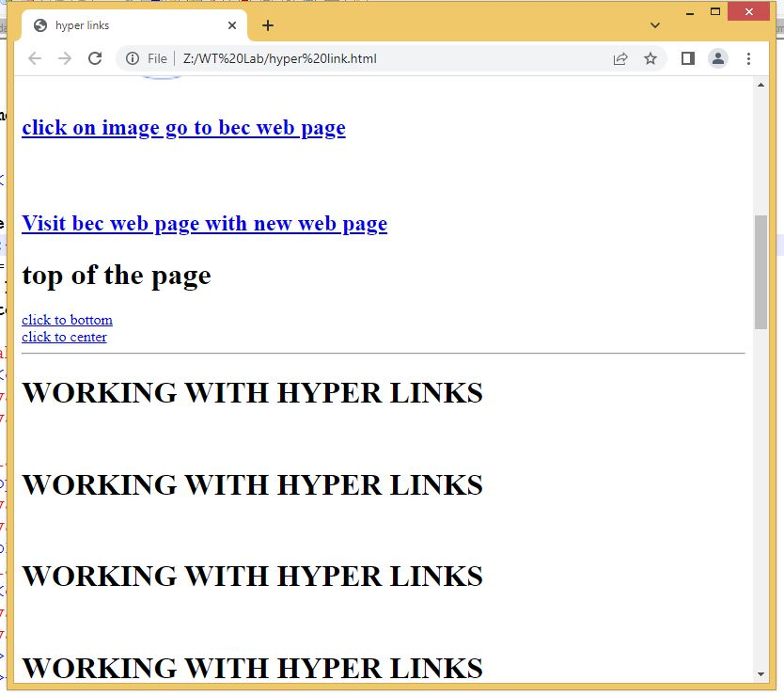

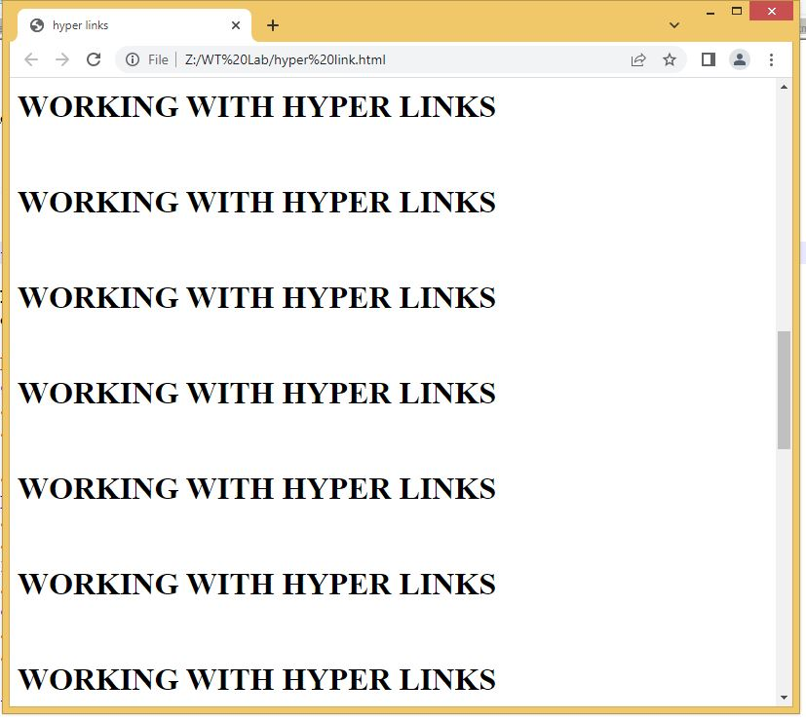

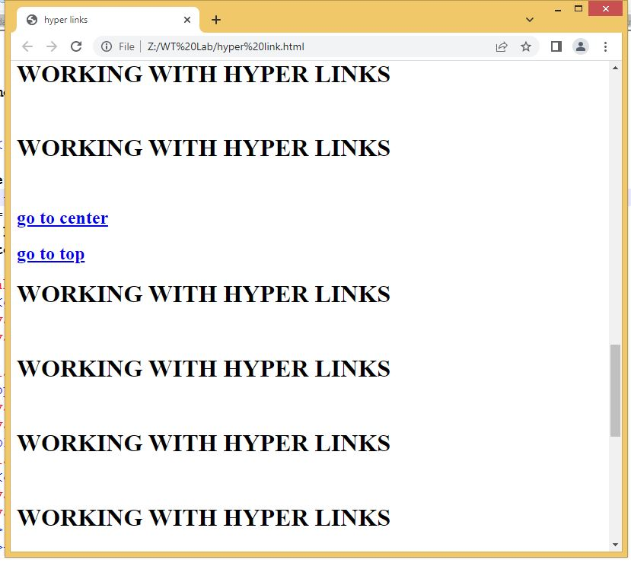

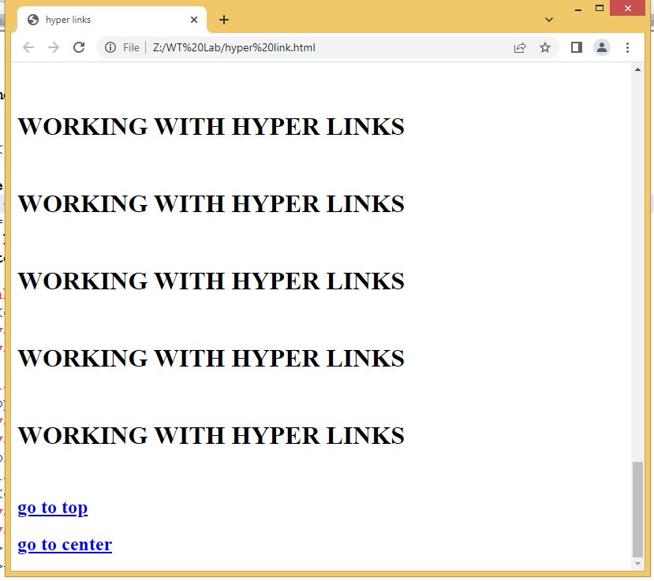

**Program-2b)**

**Aim: Design a webpage to demonstrate Id tag used in frames**

**Source code:**

**Page1:**

<!DOCTYPE html>

<html>

<head>

<title>Gmail</title>

</head>

<frameset rows="20%,80%" border="1">

<frame name="header" src="header.html">

<frameset cols="30%,70%">

<frame name="aside" src="navigation.html">

<frame name="section" src=" ">

</frameset>

<noframes>

your browser does not support frames

</noframes>

</frameset>

</html>

**Output:**

**Program-2c)**

**Aim: Demontstrate all the basic tags in html5 for Image map creation.**

**Source code:**

<!DOCTYPEhtml>

<html>

<head>

<title>image map</title>

</head>

<body>

<img src="India-map-en.svg.png" width="500" height="500" alt="india map" usemap="#india" >

<map name="india">

<area shape="circle" coords="200,350,30" href="https://ap.nic.in/">

<area shape="rect" coords="150,400,200,450" href="https://tn.nic.in/">

<area shape="circle" coords="100,100,50" href="andhramap.png">

</map>

</body>

</html>

**Output:**

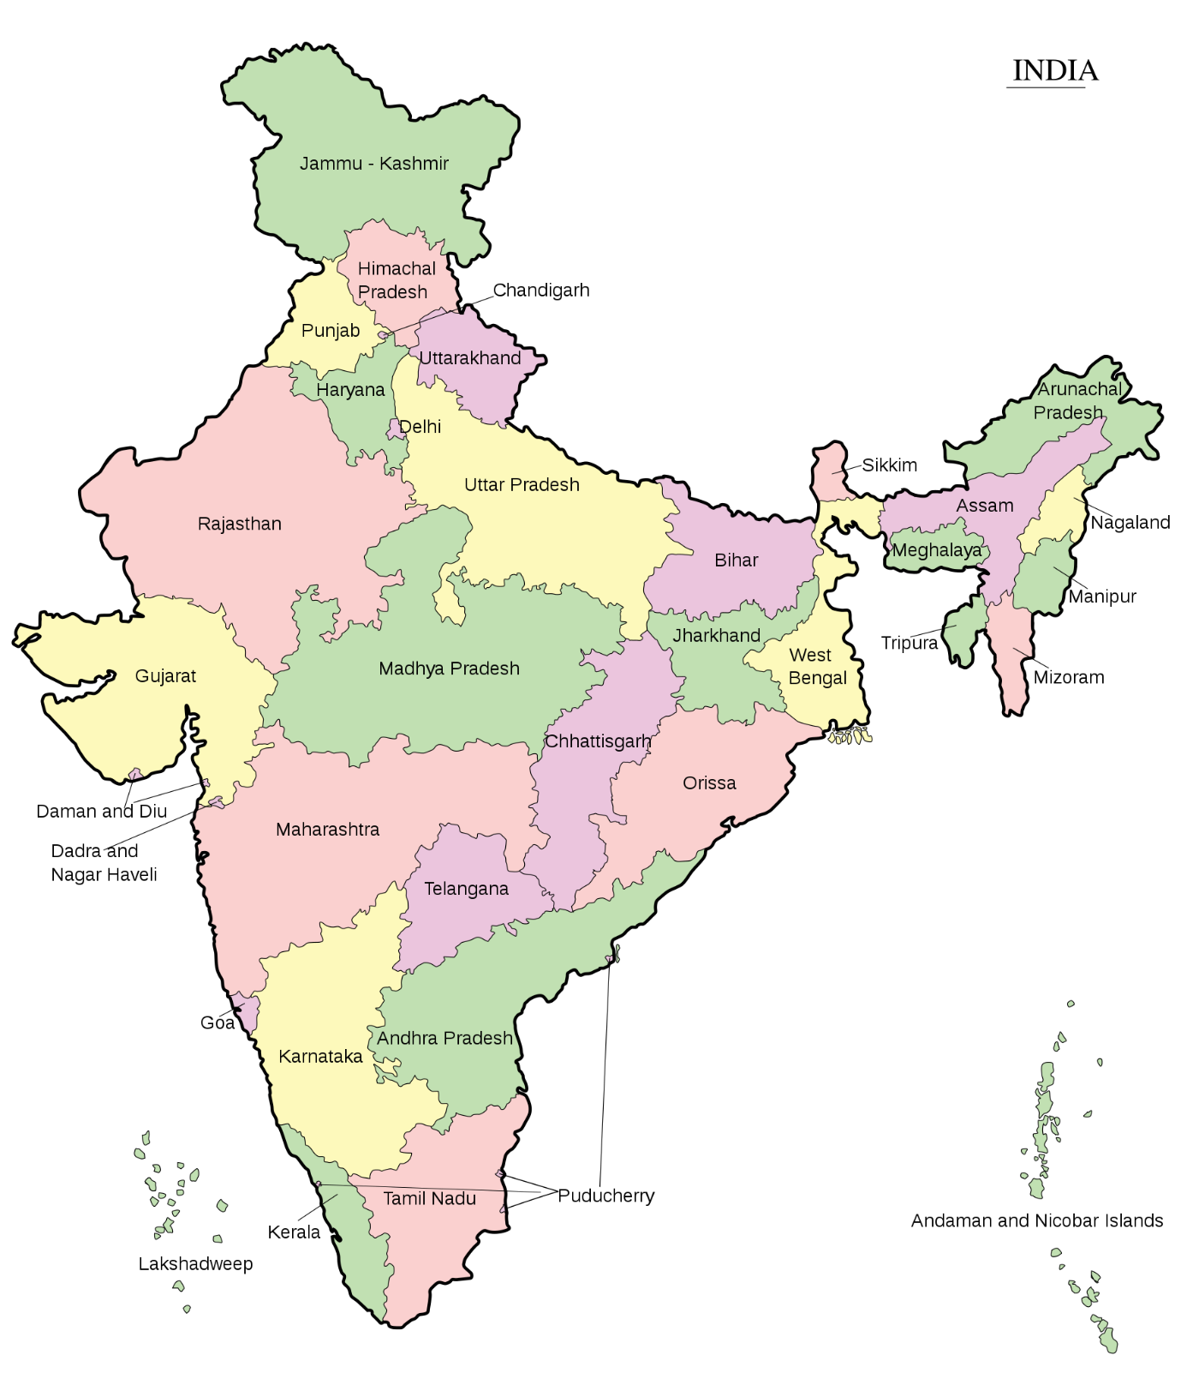

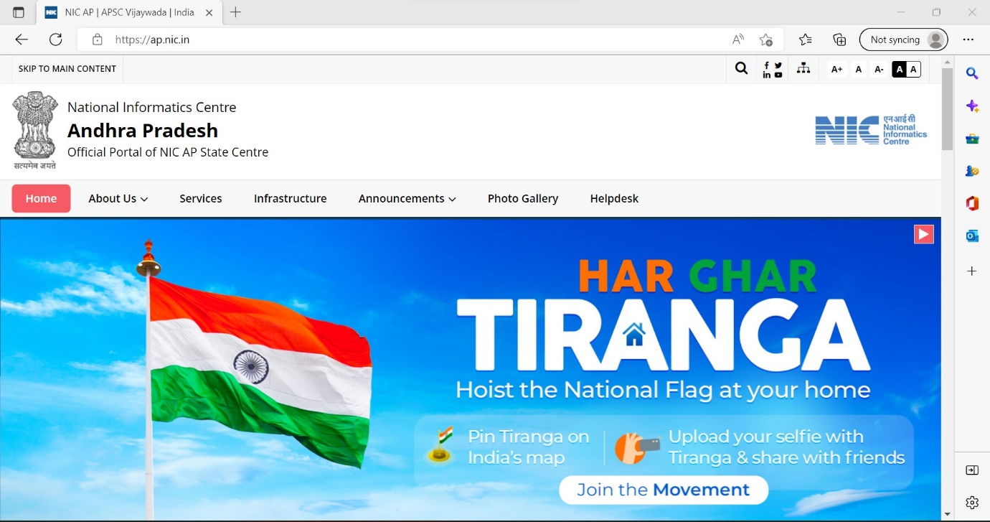

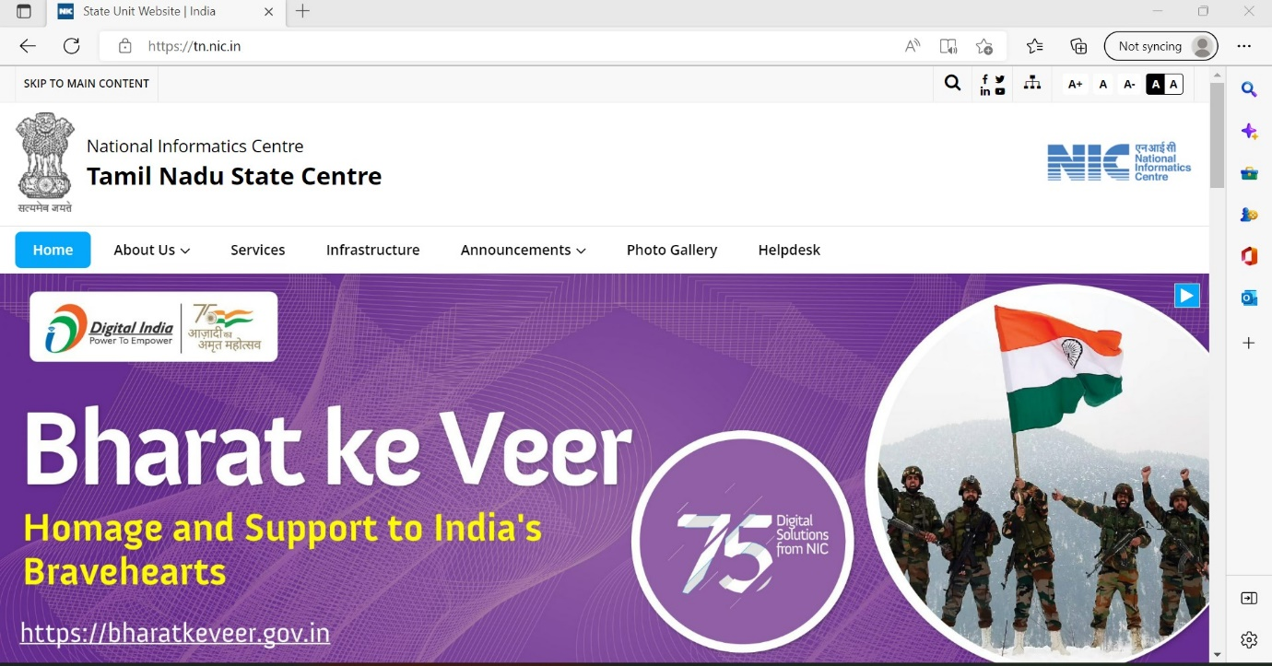

**Program-3a)**

**Aim: Write an HTML document to create registration form using all the input fields.**

**Source code:**

<!DOCTYPE html>

<html>

<head>

<title>Student Forms</title>

<link rel="stylesheet" href="style1.css">

</head>

<body>

<h1><center>student registration form</center></h1>

<form>

<label> Firstname: </label>

<input type="text" name="firstname"></input><br> <br>

<label> Lastname: </label>

<input type="text" name="lastname"></input><br> <br>

<label>Course :</label>

<select><option value="Course">Course</option>

<option value="BCA">BSC</option>

<option value="BBA">BBA</option>

<option value="B.Tech">B.Tech</option>

<option value="MBA">MBA</option>

<option value="MCA">MCA</option>

<option value="M.Tech">M.Tech</option></select><br> <br>

<label>BRANCH:</label><br>

<input type="checkbox" id="Branch" name="Branch" value="IT">IT</input><br>

<input type="checkbox" id="Branch" name="Branch" value="CSE">CSE</input><br>

<input type="checkbox" id="Branch" name="Branch" value="MECHANICAL">MECHANICAL</input><br>

<input type="checkbox" id="Branch" name="Branch" value="EEE">EEE</input><br>

<br>

<label>Gender:</label><br>

<input type="radio" id="gender" name="gender" value="male">Male</input> <br>

<input type="radio" id="gender" name="gender" value="female">Female</input><br>

<input type="radio" id="gender" name="gender" value="other">Other</input><br> <br>

<label>Phone:</label>

<input type="number" name="country code" value="+91" size="1"></input>

<input type="number" name="phone" size="10"/></input><br> <br>

<label>Address:</label><br>

<textarea cols="80" rows="5" value="address"></textarea><br> <br>

<label>Email:</lable>

<input type="email" id="email" name="email"></input><br> <br>

<label>Password:</label>

<input type="Password" id="pass" name="pass"></input><br> <br>

<input type="Button" value="Submit"></input><br><br>

<input type="reset" value="Reset"></input><br><br>

</form>

</body>

</html>

**Output:**

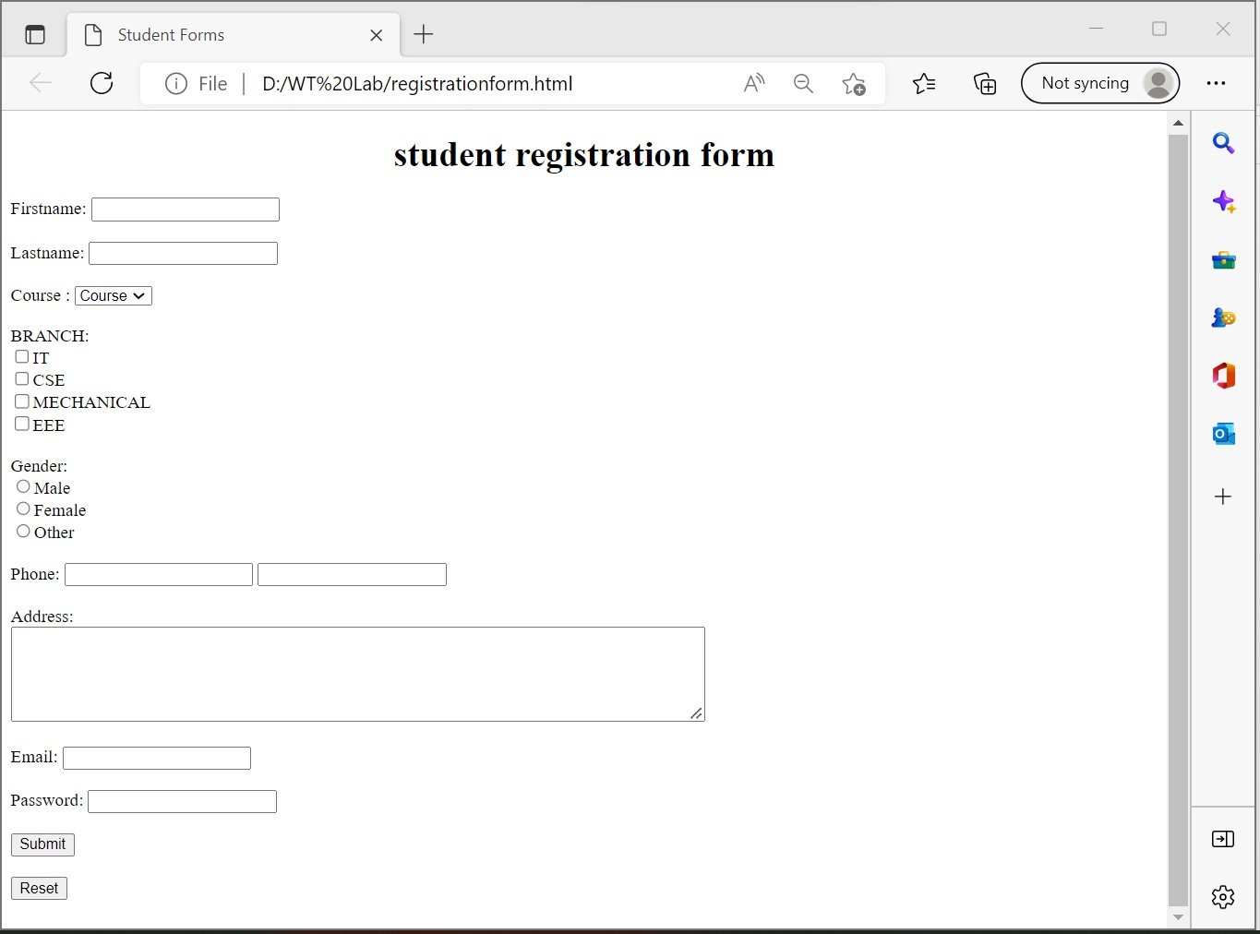

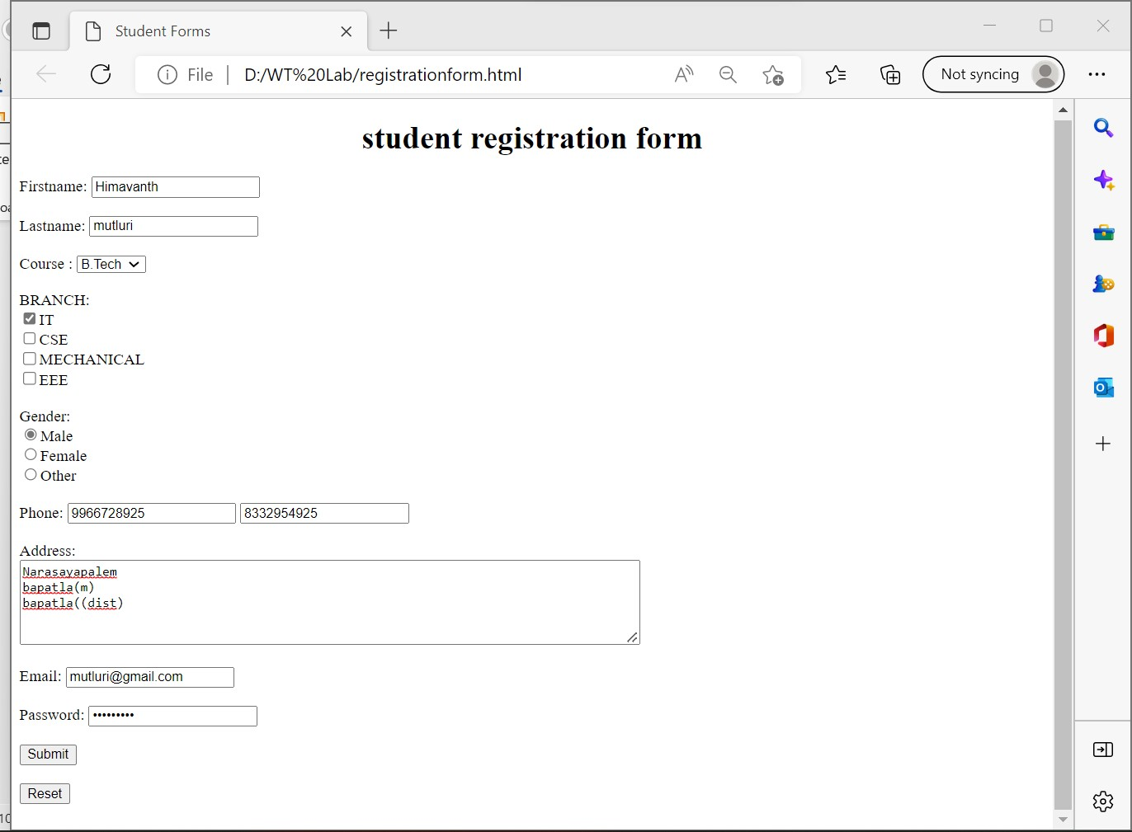

**Program-3b)**

**Aim: Write an HTML document to create a form that demnostrate the label,textara,select,option,optiongroup,legend,fieldset,datalist.**

**Source code:**

<!DOCTYPE html>

<html>

<head>

<title>Form elements</title>

</head>

<body>

<h1>Form elements</h1>

<form>

<label>Name:<input type="text"</label><br>

Fill the details:<br>

<textarea rows="10" cols="25" name="discription">Enter your details

here</textarea><br>

select any one item:<br>

<select>

<optgroup label="games">

<option value="crickt">crickt</option>

<option value="Football">Football</option>

<option value="Volleyball">Volleyball</option>

</optgroup>

<optgroup label="fruits">

<option value="apple">apple</option>

<option value="banana">banana</option>

<option value="grapes">grapes</option>

</optgroup>

<optgroup label="languages">

<option value="Hindi">Hindi</option>

<option value="Telugu">Telugu</option>

<option value="Tami">Tami</option><br>

</optgroup>

</select><br><br><br>

<fieldset>

<legend>Student details</legend>

Student Name:<input type="text"><br>

Branch:<input type="text"><br>

Reg.no<input type="text">

</fieldset>

<p>enter name of your favourite game</p>

<input type="text" name="favgame" list="games">

<datalist id="games">

<option value="crickt">

<option value="Football">

<option value="Volleyball">

</datalist>

</form>

</body>

</html>

**Output:**

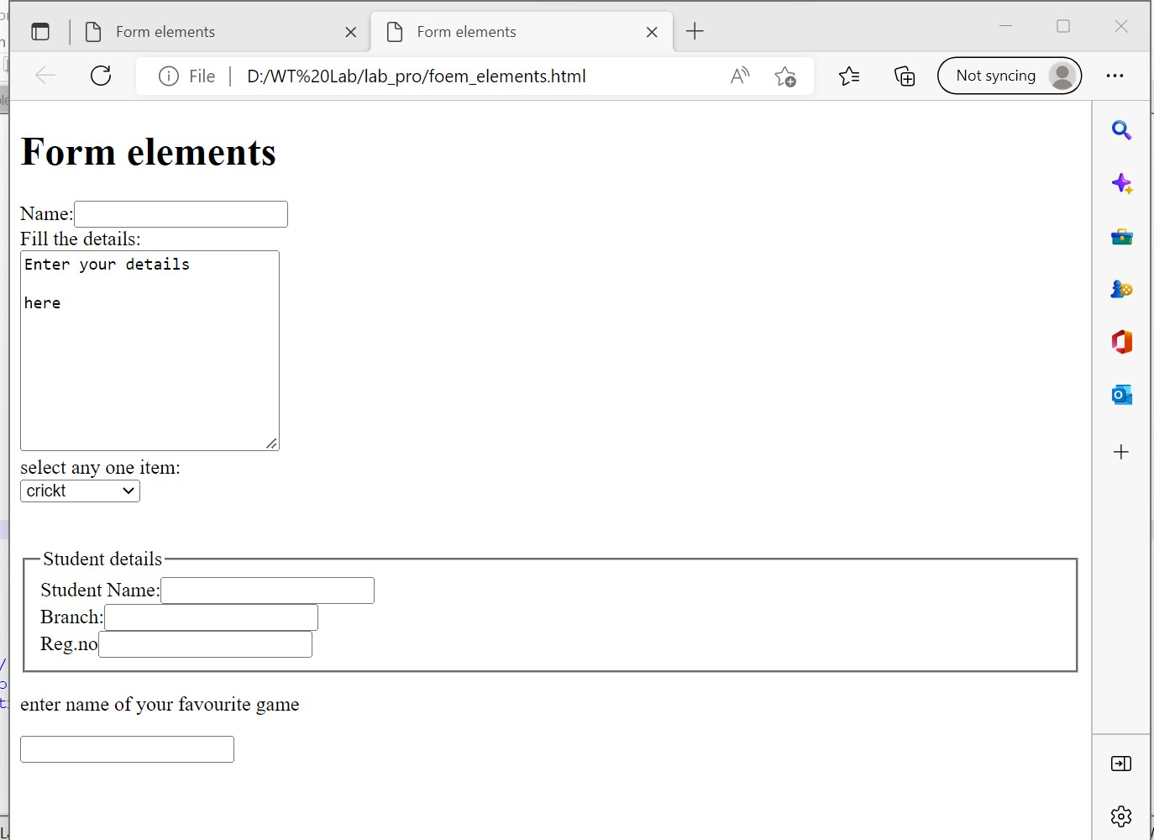

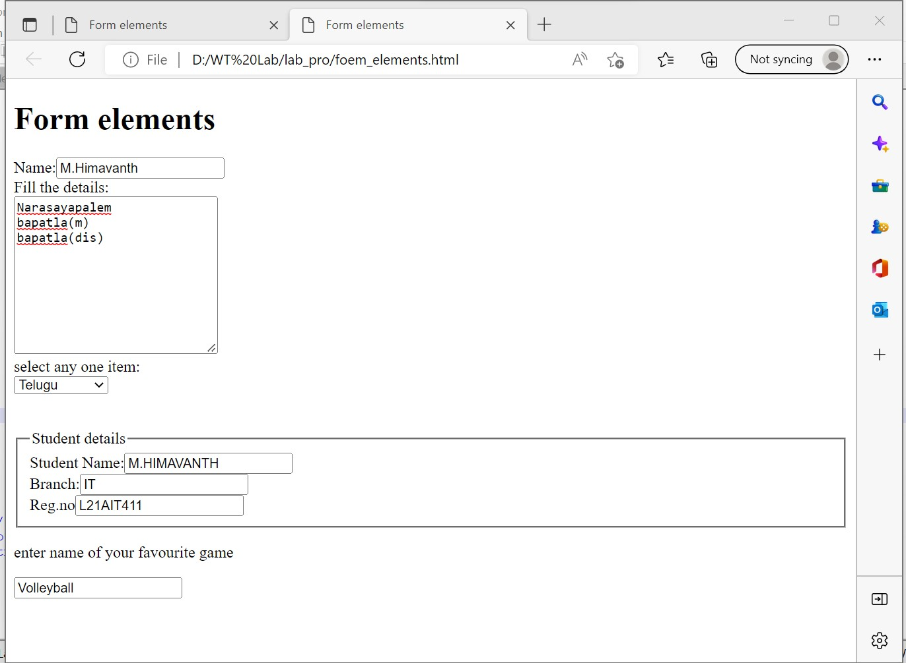

**Program-4a)**

**Aim: Demonstrate all the styles in css3**

**i) inline**

**ii) internal**

**iii)external**

**i)Inline style sheet**

**Source code:**

<!DOCTYPE html>

<html>

<head>

<title>Inline stylesheeet</title>

</head>

<body style="color:red;background-color:blue; font-size-16pt;font-family:sans-serif; >

<h1 style="font-size:18pt">Welcome to Bapatla Engineering College</h1>

<p style="font-size:16pt color:pink">Welcome to Bapatla Engineering College</h1><br><br>

<h2 style="color:ff0000;background-color:00000;font-size:14pt">Welcome to Bapatla Engineering College</h2>

<h2 style="color:ff0000;background-color:yellow;font-size:24pt;":>Welcome to Bapatla Engineering College</h2>

</body>

</html>

**Output:**

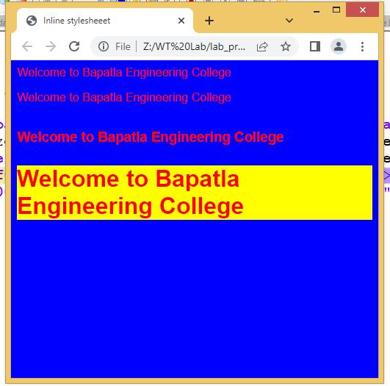

**ii)Internal style sheet**

**Source code:**

<!DOCTYPE html>

<html>

<head>

<title>Internal stylesheeet</title>

<style>

*{margin:1;}

body{

color:red;

background-color:pink;

font-family:sans-serif;}

h1{font-size:20t;}

p{font-size:16pt;color:yellow}

</style>

</head>

<body>

<h1>Welcome to Bapatla Engineering College</h1><br>

<p>Welcome to Bapatla Engineering College</h1><br><br>

<h2>Welcome to Bapatla Engineering College</h2><br>

<h3>Welcome to Bapatla Engineering College</h3>

</body>

</html>

**Output:**

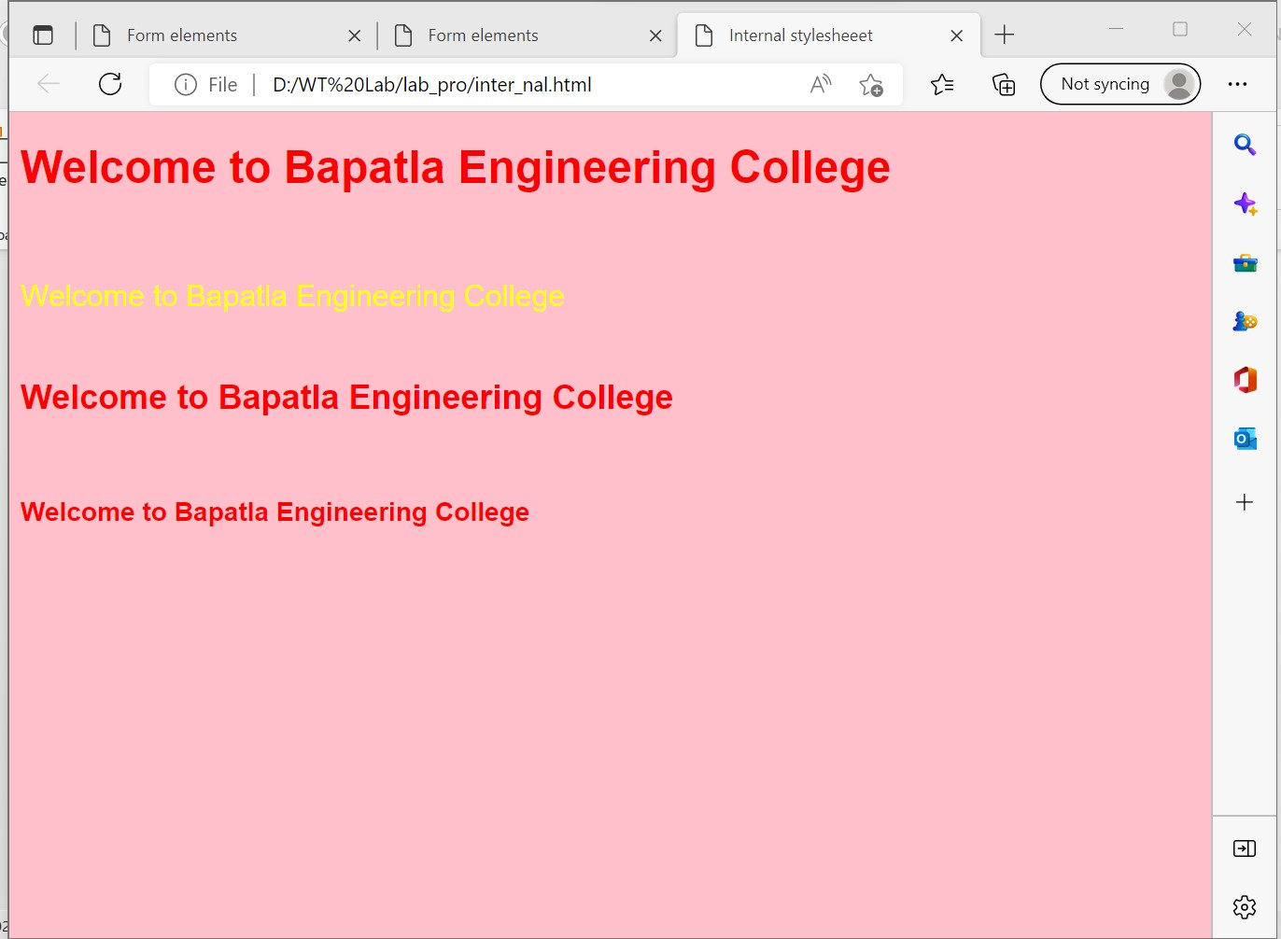

**iii)External style sheet**

**a)Linking**

**Source code:**

<!DOCTYPE html>

<html>

<head>

<title>external stylesheeet</title>

<Link rel="stylesheet" type="text/css" href="exm2.css">

</head>

<body>

<h1>external stylesheeet</h1>

<p>To empower the faculty and students with the knowledge,

skills and innovative thinking <br>to facilitate discovery in

numerous existing and <br>yet to be discovered fields of engineering,

technology and<br> interdisciplinary endeavors. </p>

</body>

</html>

**exm2.css**

Source code:

h1{font-size:18pt;

color:red;}

p.code{

font-family:Ariel;}

p{

background-color:yellow;

border-style:solid;

border-width:14px;

border-color:#00000;

}

**Output:**

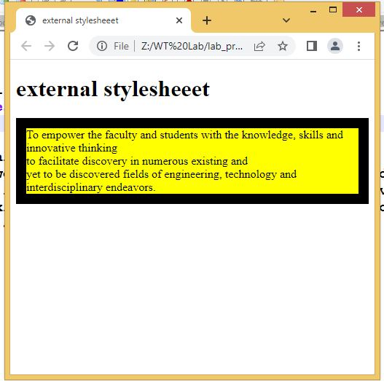

**b)Importing**

**Source code:**

<!DOCTYPE html>

<html>

<head>

<title>external stylesheeet using import</title>

<style type="text/css">

@import url("ex.css")

</style>

</head>

<body>

<h1>external through import</h1>

<p>To build centers of excellence, impart high quality

education and instill high

standards of ethics and professionalism

through strategic efforts of our dedicated

staff,<br> which allows the college to effectively

adapt to the ever changing aspects of education. </p>

</body>

</html>

**ex.css**

**Source code:**

Source code:

font-size:18pt;

color:red;}

p.code{

font-family:Ariel;}

td{padding:5px;}

p{

background-color:yellow;

border-style:solid;

border-width:14px;

border-color:#999900;

}

**Output:**

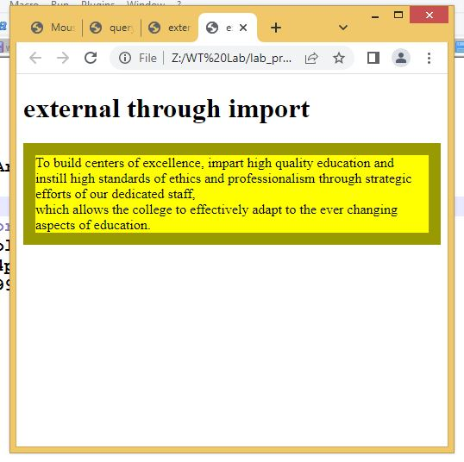

**Program-4b)**

**Aim: Demonstrate all the styles in css3 query selector**

**Source code:**

<!DOCTYPE HTML>

<html>

<head>

<title>query selector</title>

</head>

<script type="text/javascript">

function changecss()

{

document.querySelector("p").style.background="pink";

}

function changecssall()

{

list=document.querySelectorAll("p");

for(var i=0;i<list.length;i++)

{

list[i].style.background="yellow";

}

}

</script>

</head>

<body>

<p>this is HTML class</p>

<p>this is HTML class</p>

<p>this is HTML class</p>

<p>this is HTML class</p>

<p>this is HTML class</p>

<button onclick="changecss()">selector</button>

<button onclick="changecssall()">selector All</button>

</body>

</html>

**Output:**

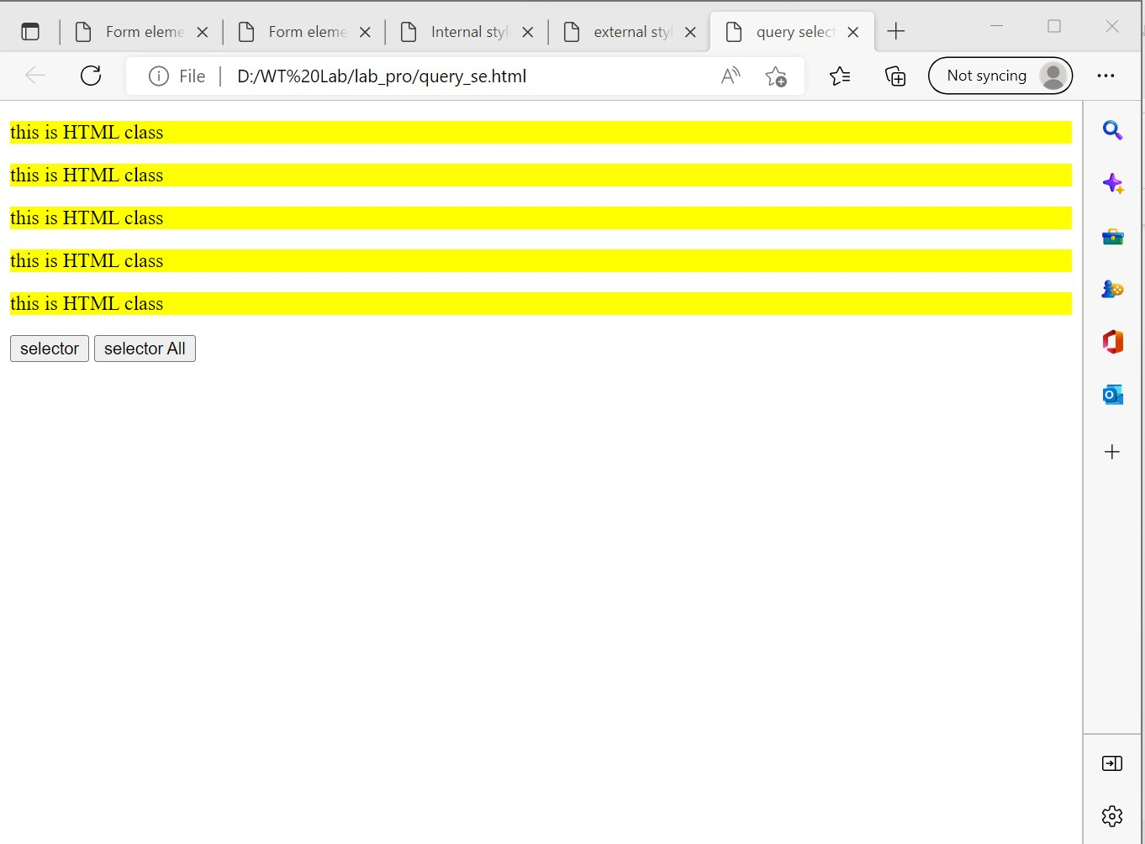

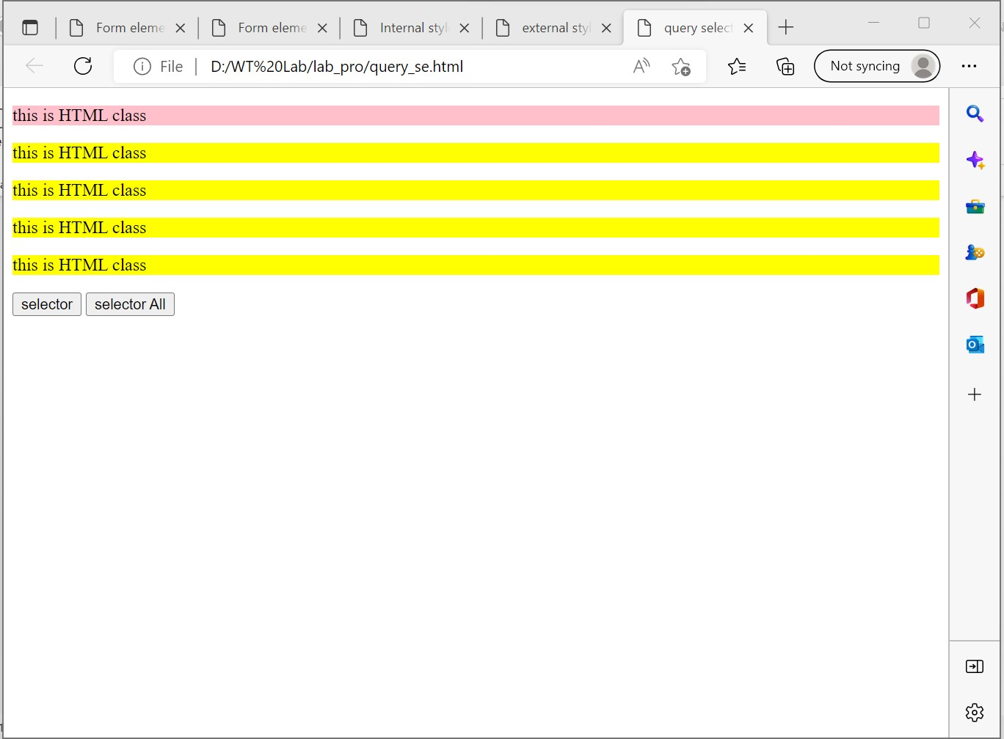

**Program-5a)**

**Aim: Write a javascript program to demonstrate the Mouse events**

**Source code:**

<!DOCTYPE html>

<html>

<head>

<title>Mouse Events</title>

<script type="text/javascript">

function mouseclick()

{

document.getElementById("click").style.background="gray";

}

function mousedblclick()

{

document.getElementById("dblclick").style.background="blue";

}

function mouseup()

{

document.getElementById("up").style.background="red";

}

function mousedown()

{

document.getElementById("down").style.background="yellow";

}

function mouseover()

{

alert("mouse over raised");

}

function mouseout()

{

alert("mouse out raised");

}

function mousewheel()

{

alert("mouse wheel raised");

}

function mousemove()

{

alert("mouse move raised");

}

</script>

</head>

<body>

<h2 id="click" onclick="mouseclick()">Mouse click</h2>

<h2 id="dblclick" onclick="mousedblclick()">Mouse dblclick</h2>

<h2 id="up" onclick="mouseup()">Mouse up</h2>

<h2 id="down" onclick="mousedown()">Mousedown</h2>

<img src="bc.jpg"" width="60" height="70" onmousemove="mousemove()">

<img src="b4.jpg"" width="50" height="70" onmouseover="mouseover()">

<img src="beclogo.jpeg" width="50" height="70" onmousewheel="mousewheel()">

<img src="bc.jpg" width="50" height="70" onmouseout="mouseout()">

</body>

</htm>

**Output:**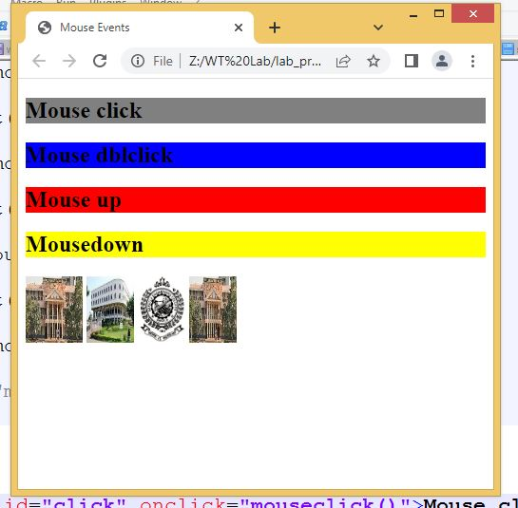

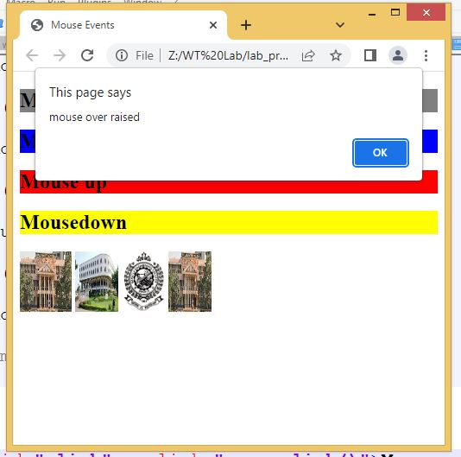

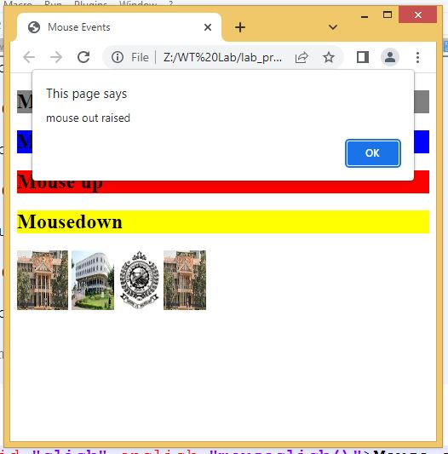

**Program-5b)**

**Aim: Write a javascript program to demonstrate the Form events**

**Source code:**

<!DOCTYPe html>

<html>

<head>

<title>Form events</title>

<script type="text/javascript">

function inpfocus()

{

document.getElementById("uname").style.background="yellow"

}

function inpblur()

{

document.getElementById("uname").style.background="red"

}

function inpinvalid()

{

document.getElementById("msg").innerHTML="you are not submitting the form";

}

function inpselect()

{

alert("you are selected the content");

}

function inpsubmit()

{

alert("submit the form");

}

function inpreset()

{

alert("reset the form ?");

}

function inpchange()

</html>

{

alert("you are changed the content");

</html>

}

</script>

</head>

<body>

<form>

EnterName:<input id="uname" type="text" onfocus="inpfocus()" onblur="inpblur()"

oninvalid="inpinvalid()" required onselect="inpselect()" onsubmit="inpsubmit()"

onreset="inpreset()" onchange="inpchange()";>

<br><input type="submit" value="submit">

<input type="reset" value="reset">

<p id="msg"></p>

</form>

</body>

</html>

**Output:**

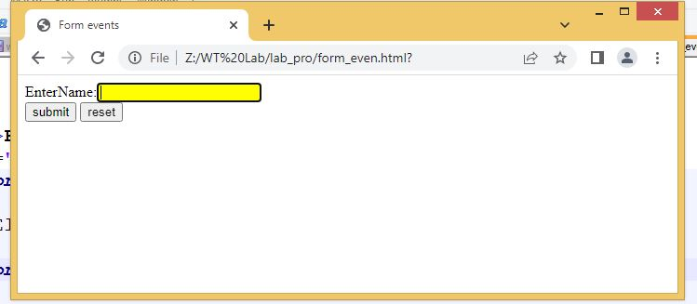

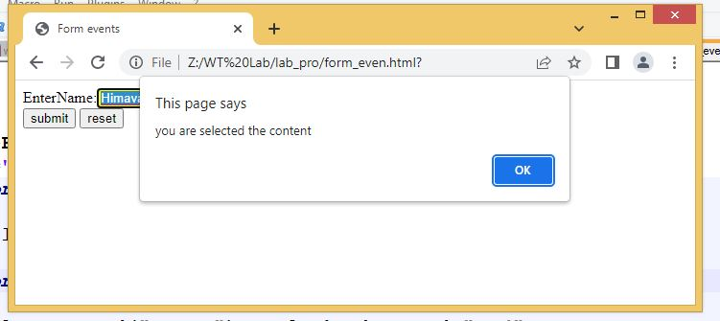

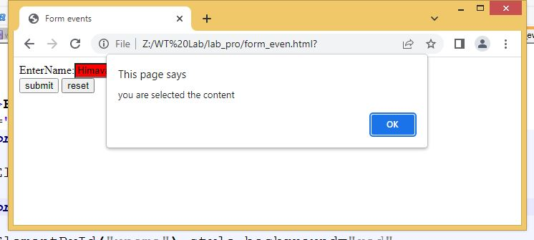

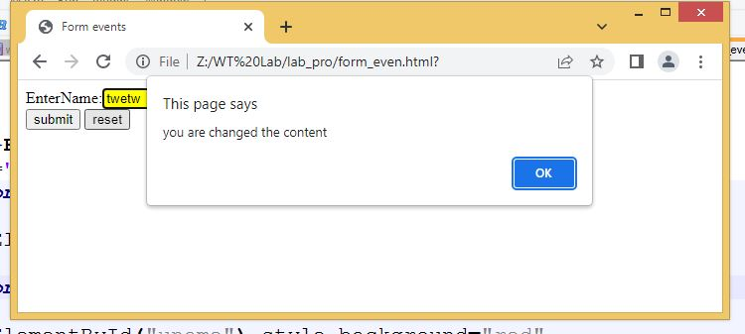

**Program-5c)**

**Aim: Write a javascript program to demonstrate the pop-ups**

**Source code:**

<!DOCTYPE html>

<html>

<head>

<title>Demonstrate Popup boxes</title>

<script type="text/javascript">

function alertmsg()

{

alert("This is alert msg");

}

function confirmmsg()

{

confirm("Do you want to delete the file");

}

function promptmsg()

{

var msg=prompt("plz enter your otp");

Document.getElementById("pmsg").innerHTML="yourmsg:"+msg;

}

</script>

</head>

<body>

<h1>Dempnstrate Popup boxes</h1>

<button onClick="alertmsg()">Alertbox</button><br>

<button onClick="confirmmsg()">confirmbox</button><br>

<button onClick="promptmsg()">promptbox</button>

<p id="pmsg"></p>

</body>

</html>

**Output:**

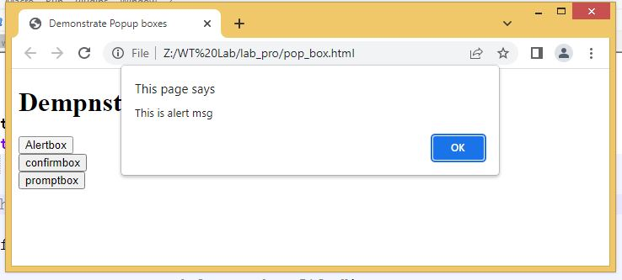

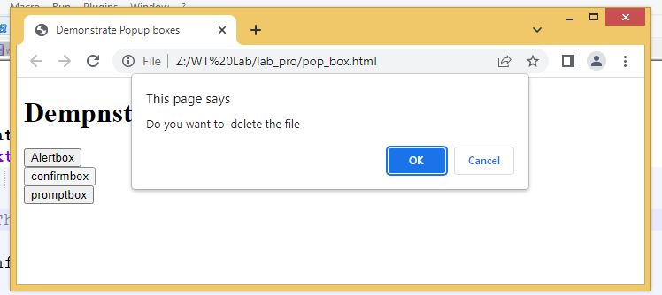

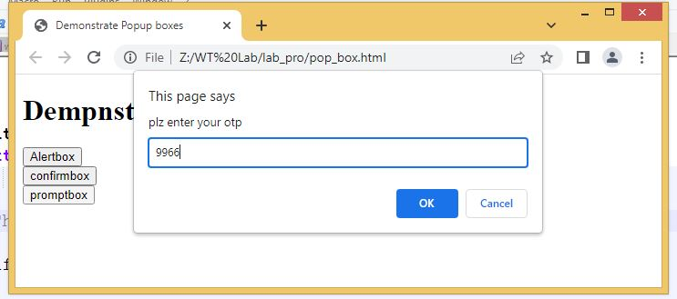

**Program-6a)**

**Aim: Write a javascript program to demonstrate the String objects.**

**Source code:**

<!DOCTYPE html>

<html>

<head>

<title> String Object</title>

</head>

<body >

<script type="text/javascript">

document. write("<h2>String Objects </h2>");

var str= "welcome to html5";

var str1= "welcome to JS";

document.write("Length of str:"+str.length);

document.write("<br>Character at 5 position:"+str.charAt(5));

document.write("<br>Concat str & str1:"+str.concat(str1));

document.write("<br>Index of 'm' in str:"+str.indexOf('m'));

document.write("<br> last Index of 'm' in str:"+str.lastIndexOf('m'));

document.write("<br>Replace html5 to css3 in str:"+str.replace("html5","css3"));

document.write("<br>slice the test from 0-7 in str:"+str.slice(0,7));

document.write("<br>split the str based on space:"+str.split(" "));

document.write("<br>Upper case of str text:"+str.toUpperCase());

document.write("<br>lower case of str text:"+str.toLowerCase());

document.write("<h2> Wrapper methods in String Objects </h2>");

document.write("small text:"+str.small());

document.write("<br>Big text:"+str.big());

document.write("<br>Bold text:"+str.bold());

document.write("<br>Font color:"+str.fontcolor("yellow"));

document.write("<br>Font size:"+str.fontsize("10px"));

document.write("<br>Italic text:"+str.italics())

document.write("<br>subscript:"+str.sub());

document.write("<br>supscript:"+str.sup());

document.write("<br>Text Blink:"+str.blink());

</script>

</body>

</html>

**Output:**

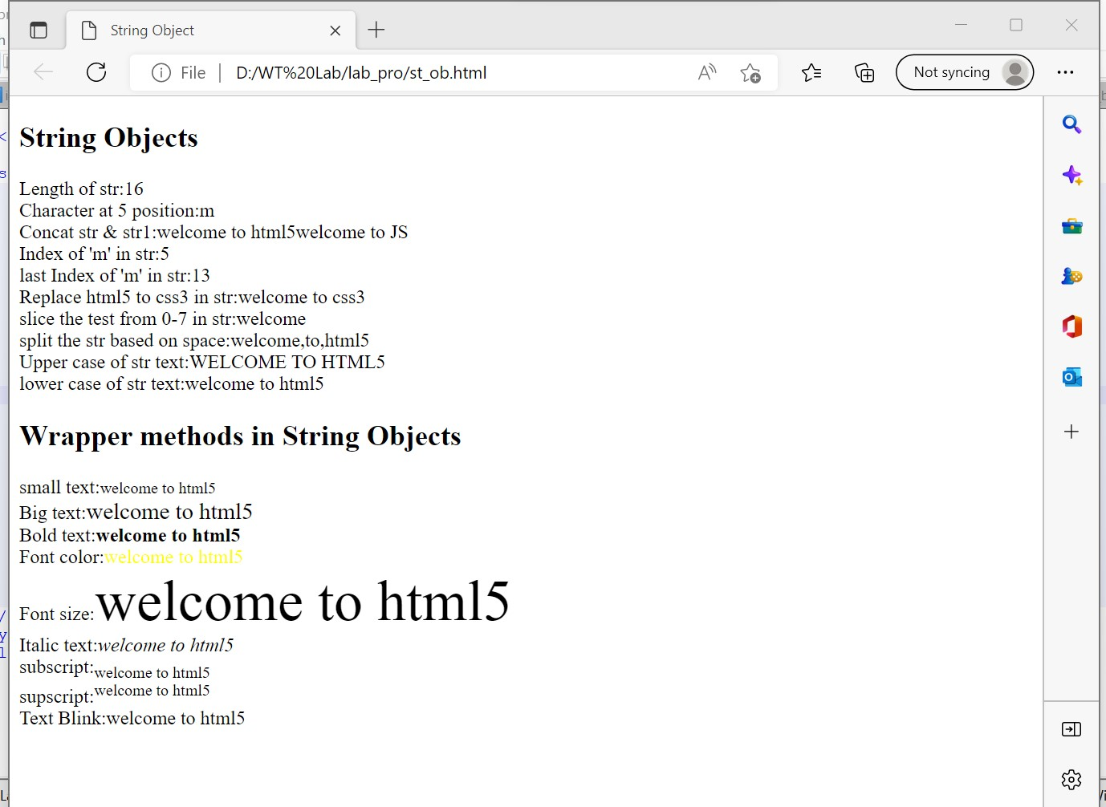

**Program-6b)**

**Aim: Write a javascript program to demonstrate the Math object.**

**Source code:**

<!DOCTYPE html>

<html>

<head>

<title> Math Object</title>

</head>

<body >

<script type="text/javascript">

document.write("<h2>MATH OBJECTS </h2>");

document.write("Euler's number E:"+Math.E);

document.write("<br>natural logarithmic of 2:"+Math.LN2);

document.write("<br>natural logarithmic of 7:"+Math.LN7);

document.write("<br>base-4 logarithmic of E:"+Math.LOG4E);

document.write("<br> base-10 logarithmic of E:"+Math.LOG10E);

document.write("<br>Number value of PI:"+Math.PI);

document.write("<br>Square root of 5:"+Math.SQRT1_5);

document.write("<br> Square root of 4:"+Math.SQRT4);

document.write("<h2>Math object methods</h2>");

document.write("absolute value of pi:"+Math.abs(Math.PI));

document.write("<br>natural logarithm of 20:"+Math.log(20));

document.write("<br>max value among (24,96,57,08,99):"+Math.max(24,96,57,08,99));

document.write("<br>min value among (12,23,32,43,4):"+Math.min(12,23,32,43,4));

document.write("<br>the value of 7 to the power of 2:"+Math.pow (7,2));

document.write("<br>random number between 0 and 1:"+Math.random());

document.write("<br>square root of 31:"+Math.sqrt(31));

</script>

</body>

</html>

**Output:**

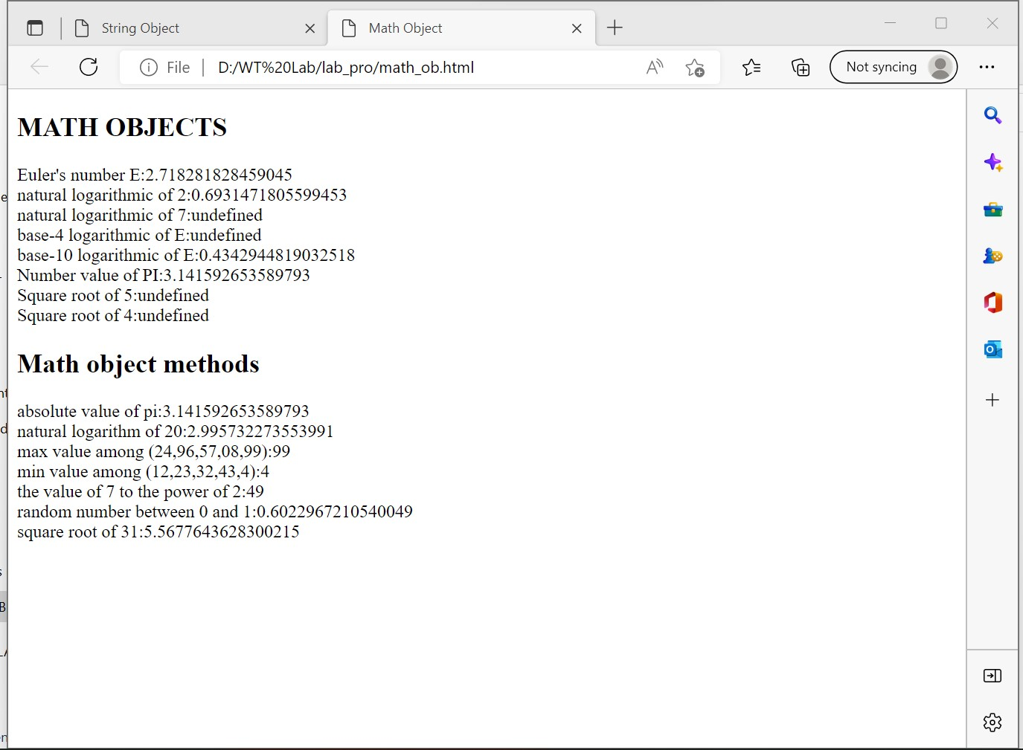

**Program-6c)**

**Aim: Write a javascript program to demonstrate the Date object.**

**Source code:**

<!DOCTYPE HTML>

<html>

<head>

<title>Document Object</title>

</head>

<body>

<h2>Document Object</h2>

<h2>Images</h2>

Iamge 1:<img id ="imgl" src="b4.jpg" width="100" height="100">

Iamge 2:<img id ="img2" src="bc.jpg" width="100" height="100">

<h2>Links</h2>

<a id="link1" href="list.html">Pagel</a>

<a id ="link2" href="log_tags.html">Page2</a>

<h2>Docuemnt object methods</h2>

<button onclick="open_doc()">Open Docuemnt</button>

<script type="text/javascript">

document.write("<h2>Document object collection</h2>");

document.write("Number of images:"+document.images.length);

document.write("<br>Number of links:"+document.links.length);

document.write("<h2>Document object properties</h2>");

document.write("Title of docuemnt:"+document.title);

document.write("<br>URL of docuemnt:"+document.URL);

document.write("<br> state of docuemnt:"+document.readyState);

document.write("<br>lastmodified of docuemnt:"+document.lastModified);

function open_doc(){

var mywindow = window.open();

mywindow.document.open();

mywindow.document.write("<h1>Welcome to document</h1>");

mywindow.document.close();

}

</script>

</body>

</html>

**Output:**

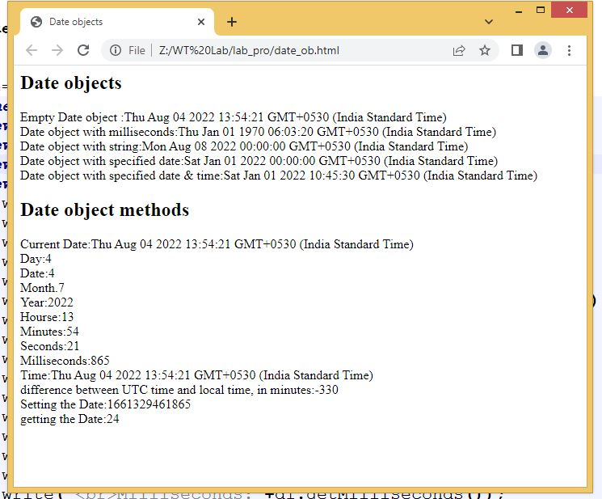

**Program-7a)**

**Aim: Write a javascript program to demonstrate Window objects**

**Source code:**

<!DOCTYPE html>

<html>

<head>

<title>Window object</title>

</head>

<body>

<h2>Frames</h2>

<iframe src="list.html" width="250" height="200"></iframe>

<iframe src="log_tags.html" width="250" height="200"></iframe>

<h2>window object methods</h2>

<button id="but1" onclick="win=window.open()">Open Window</button>

<button id="but1" onclick="win.close()">close Window</button>

<button id="but1" onclick="window.alert('Alert Message')">Alert</button>

<button id="but1" onclick="window.prompt('prompt Message)">Prompt</button>

<button id="but1" onclick="window.confirm('confirm message')">confirm</button>

<button id="but1" onclick="win.moveBy(140,150)">Move by Window 200,170 pixel</button>

<h2>window object properties</h2>

<script type="text/javascript">

document.write("Number of Frames:"+window.length);

window.frames[2].location="list.html";

document.write("<br>height of the windows content area(viewport)including scrollbars:"+window.innerHeight);

document.write("<br>width of the windows content area(viewport)including scrollbars:"+window.innerWidth);

document.write("<br>height of the browser window,including toolbars/scrollbars:"+window.outerHeight);

document.write("<br>width of the browser window,including toolbars/scrollbars:"+window.outerWidtht);

</script>

</body>

</html>

**Output:**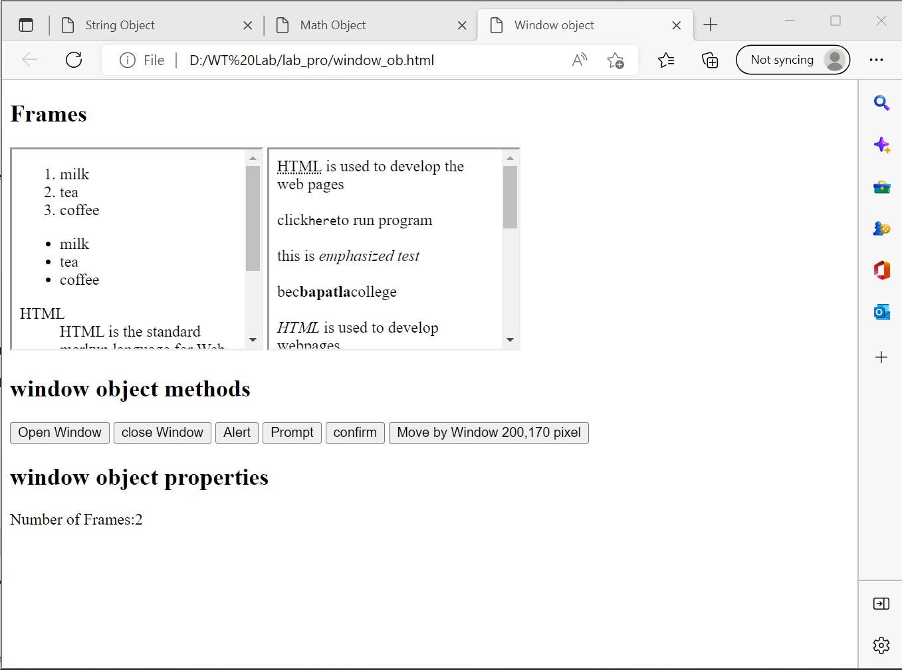

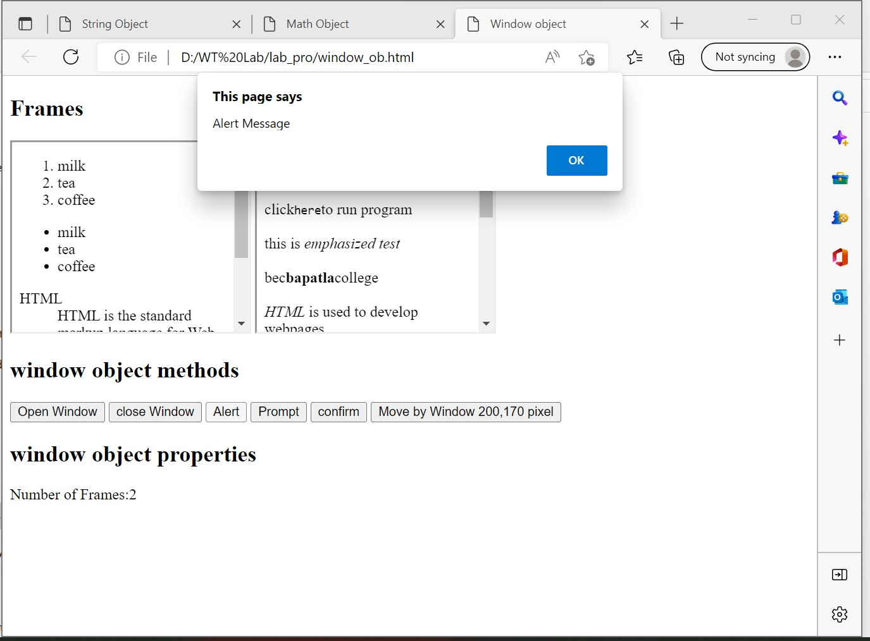

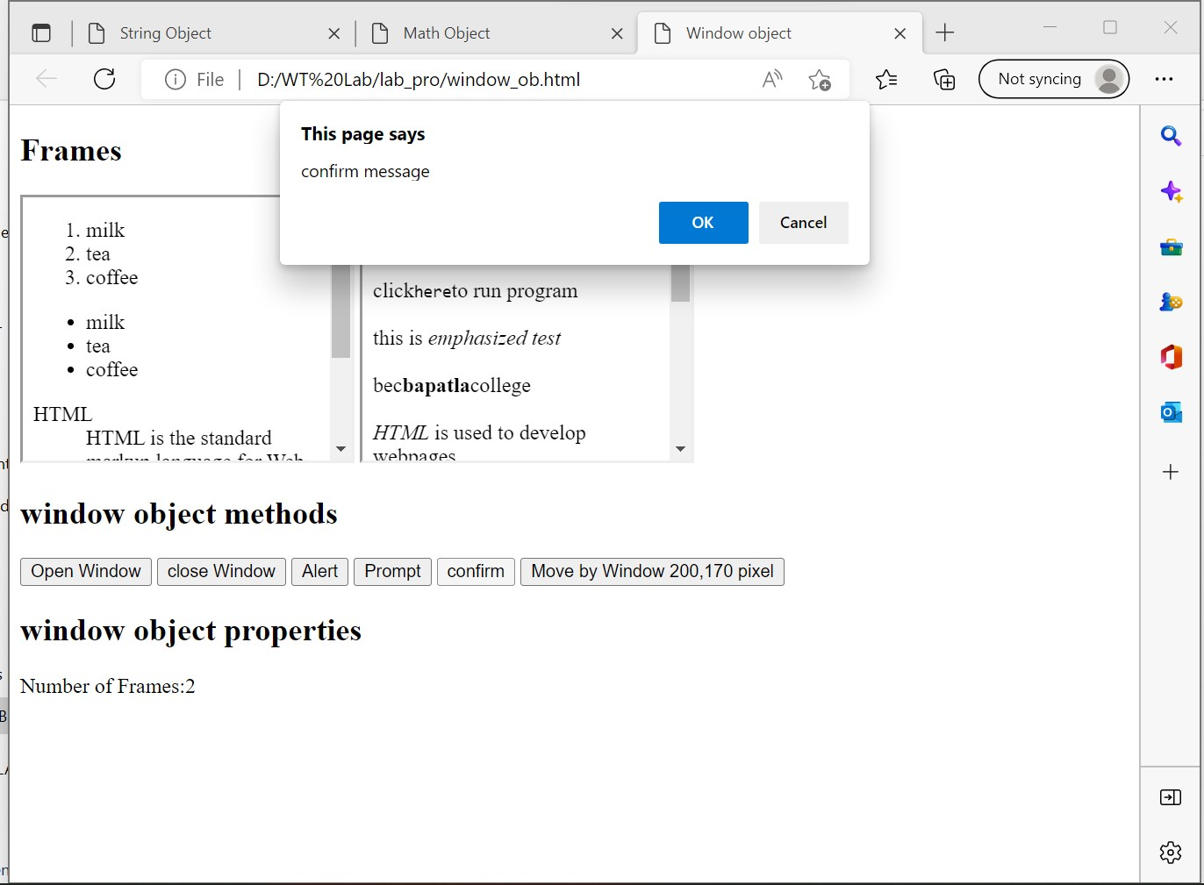

**Program-7b)**

**Aim: Write a javascript program to demonstrate document objects**

**Source code:**

<!DOCTYPE HTML>

<html>

<head>

<title>Document Object</title>

</head>

<body>

<h2>Document Object</h2>

<h2>Images</h2>

Iamge 1:<img id ="imgl" src="b4.jpg" width="100" height="100">

Iamge 2:<img id ="img2" src="bc.jpg" width="100" height="100">

<h2>Links</h2>

<a id="link1" href="list.html">Pagel</a>

<a id ="link2" href="log_tags.html">Page2</a>

<h2>Docuemnt object methods</h2>

<button onclick="open_doc()">Open Docuemnt</button>

<script type="text/javascript">

document.write("<h2>Document object collection</h2>");

document.write("Number of images:"+document.images.length);

document.write("<br>Number of links:"+document.links.length);

document.write("<h2>Document object properties</h2>");

document.write("Title of docuemnt:"+document.title);

document.write("<br>URL of docuemnt:"+document.URL);

document.write("<br> state of docuemnt:"+document.readyState);

document.write("<br>lastmodified of docuemnt:"+document.lastModified);

function open_doc(){

var mywindow = window.open();

mywindow.document.open();

mywindow.document.write("<h1>Welcome to document</h1>");

mywindow.document.close();

}

</script>

</body>

</html>

**Output:**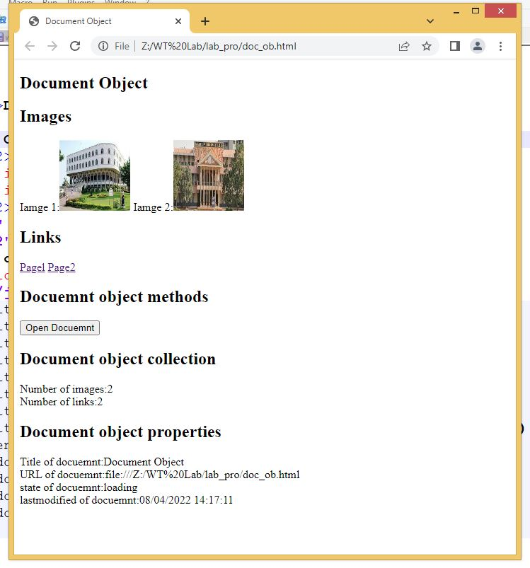

**Program-8a)**

**Aim: Write a javascript program to create, delete, duplicate and insert a node before element using DOM node interface.**

**Source code:**

<!DOCTYPE html>

<html>

<head>

<title>node interface</title>

<script type="text/javascript">

function create_node()

{

var link=document.createElement("a");

link.setAttribute("id","li");

link.setAttribute("href","bc.jpg");

link.setAttribute("width","100");

link.setAttribute("height","100");

text=document.createTextNode("this is link ");

link.appendChild(text);

document.body.appendChild(link);

}

function delete_node()

{

child=document.getElementById("li");

document.body.removeChild(child);

}

function clone_node()

{

link=document.getElementById("li");

c=link.cloneNode(true);

document.body.appendChild(c);

}

function insert_node()

{

link=document.getElementById("ll");

para=document.createElement("p");

para.setAttribute("id","p1");

text=document.createTextNode("This is html class");

para.appendChild(text);

document.body.insertBefore(para,link);

}

</script>

</head>

<body>

<div id="d">

<h2>Node interface methods</h2>

<button onclick="create_node()">create link</button>

<button onclick="delete_node()">remove link</button>

<button onclick="clone_node()">clone link</button>

<button onclick="insert_node()">insert paragraph before link</button>

</div>

</body>

</html>

**Output:**

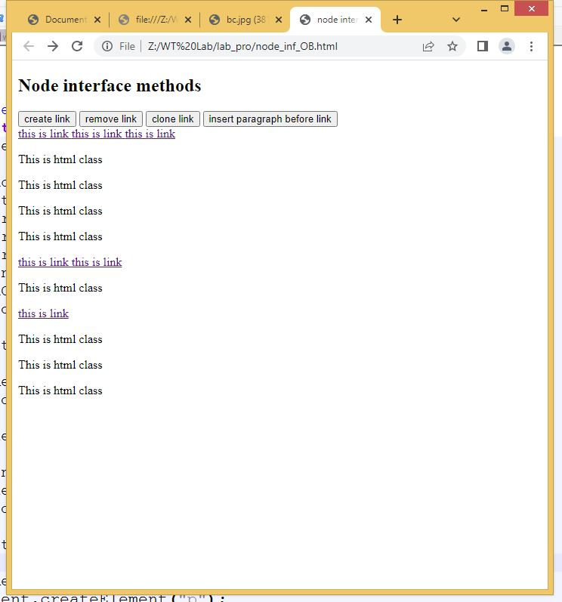

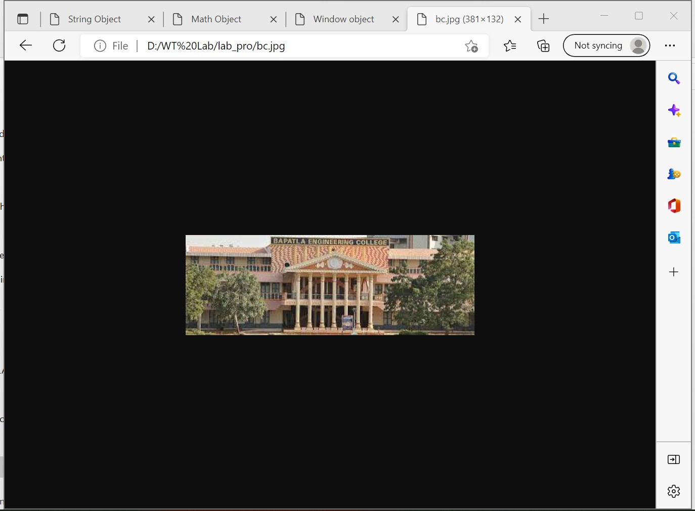

**Program-8b)**

**Aim: Develop simple web application calculator**

**Source code:**

<!DOCTYPE html>

<html>

<head>

<title>calculator</title>

<script type="text/javascript">

function display(v)

{

val=document.getElementById("imp").value;

val=val+v;

document.getElementById("imp").value=val;

}

function clearscreen()

{

document.getElementById("imp").value=" ";

}

function operation()

{

val=document.getElementById("imp").value;

res=eval(val);

document.getElementById("imp").value=res;

}

</script>

</head>

<body>

<table border="5px">

<tr>

<td colspan="4" border="2px"><input type="text" id="imp" style="text-align:right"</td>

</tr>

<tr>

<td style="text-align:center" ><button onclick="display('1')">1</button></td>

<td style="text-align:center"><button onclick="display('2')">2</button></td>

<td style="text-align:center"><button onclick="display('3')">3</button></td>

<td style="text-align:center"><button onclick="display('+')">+</button></td>

</tr>

<tr>

<td style="text-align:center"><button onclick="display('4')">4</button></td>

<td style="text-align:center"><button onclick="display('5')">5</button></td>

<td style="text-align:center"><button onclick="display('6')">6</button></td>

<td style="text-align:center"><button onclick="display('-')">-</button></td>

</tr>

<tr>

<td style="text-align:center"><button onclick="display('7')">7</button></td>

<td style="text-align:center"><button onclick="display('8')">8</button></td>

<td style="text-align:center"><button onclick="display('9')">9</button></td>

<td style="text-align:center"><button onclick="display('')">*</button></td>

</tr>

<tr>

<td style="text-align:center"><button onclick="clearscreen('c')">c</button></td>

<td style="text-align:center"><button onclick="display('0')">0</button></td>

<td style="text-align:center"><button onclick="operation('=')">=</button></td>

<td style="text-align:center"><button onclick="display('/')">/</button></td>

</tr>

</table>

</body>

</html>

**Output:**

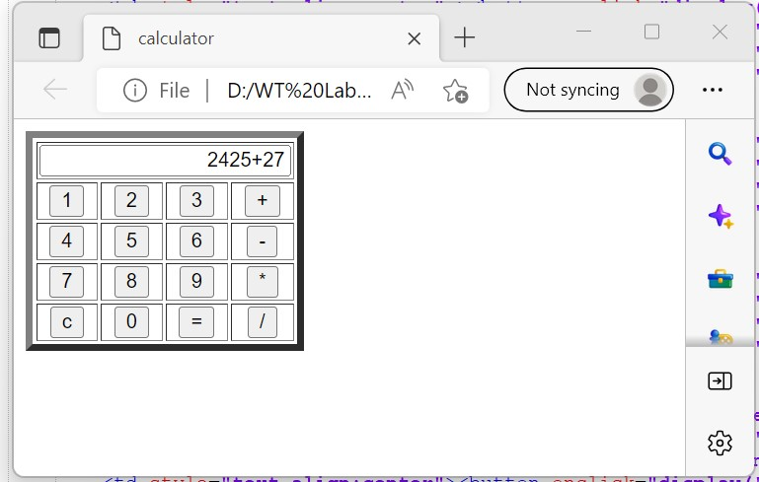

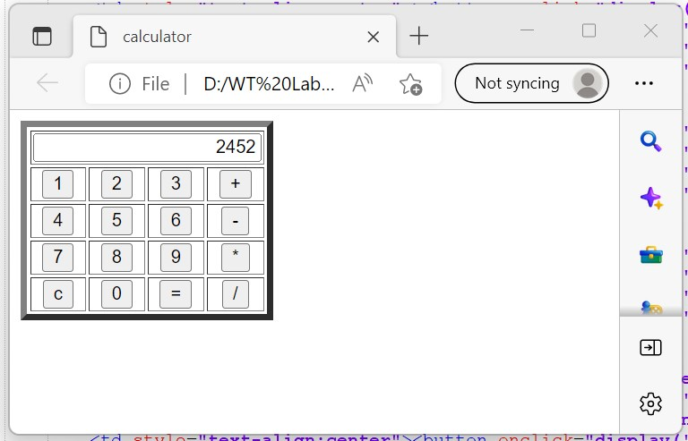

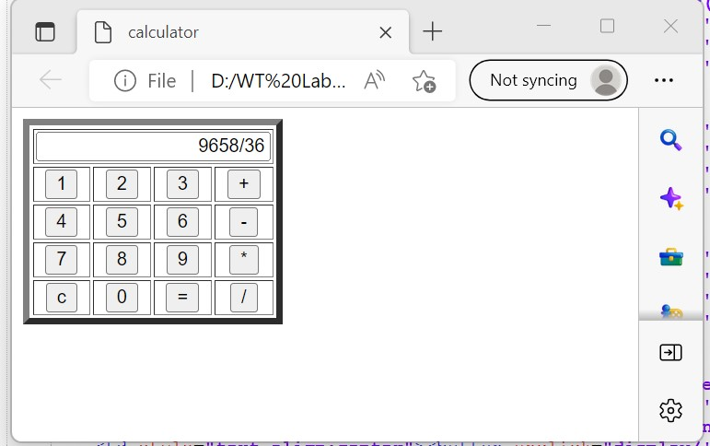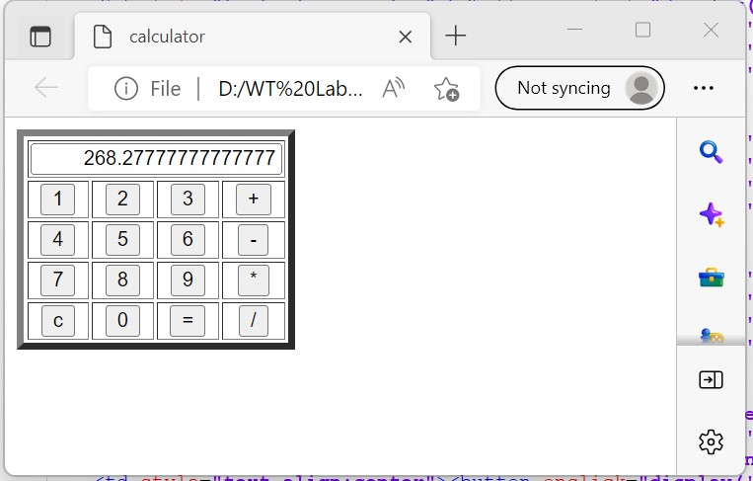

**Program-9a)**

**Aim:**

**Source code:**

<?xml version="1.0"?>

<!DOCTYPE student [

<!ELEMENT student (name,regd,address)>

<!ELEMENT name (#PCDATA)>

<!ELEMENT regd EMPTY>

<!ATTLIST regd id CDATA "411">

<!ELEMENT address (dno,street,village)>

<!ELEMENT dno (#PCDATA)>

<!ELEMENT street (#PCDATA)>

<!ELEMENT village (#PCDATA)>

]>

<student>

<name>HIma</name>

<regd id="411"/>

<address>

<dno>9-29/2</dno>

<street>center</street>

<village>narasayapalem</village>

</address>

</student>

**Output:**

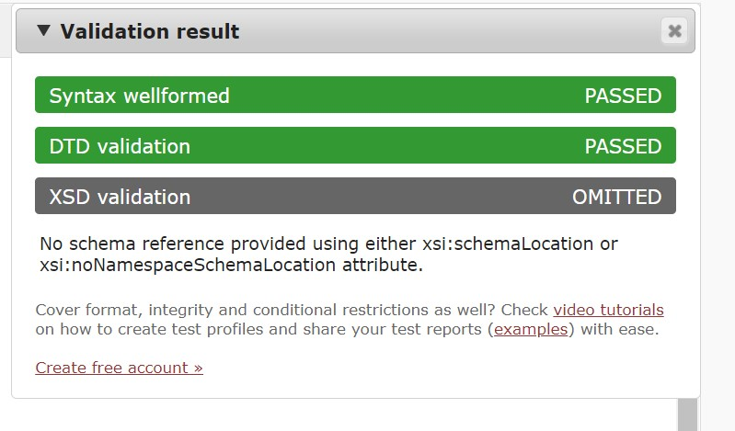

**Program 10)**

**Aim: XSD file**

**Source code:**

**XSDxml.xml**

<?xml version="1.0"?>

<student branch="it">

<name>Hima</name>

<regd>L21AIT411</regd>

<dept>IT</dept>

<section>A</section>

</student>

**XSD.xds**

<?xml version="1.0"?>

<xs:schema xmlns:xs= "http://www.w3.org/2001/XMLSchema">

<xs:element name="student">

<xs:complexType>

<xs:sequence>

<xs:element name="name" type="xs:string"/>

<xs:element name="regd" type="xs:string"/>

<xs:element name="dept" type="xs:string"/>

<xs:element name="section" type="xs:string"/>

</xs:sequence>

<xs:attribute name="branch" type="xs:string"/>

</xs:complexType>

</xs:element>

</xs:schema>

**Output:**

